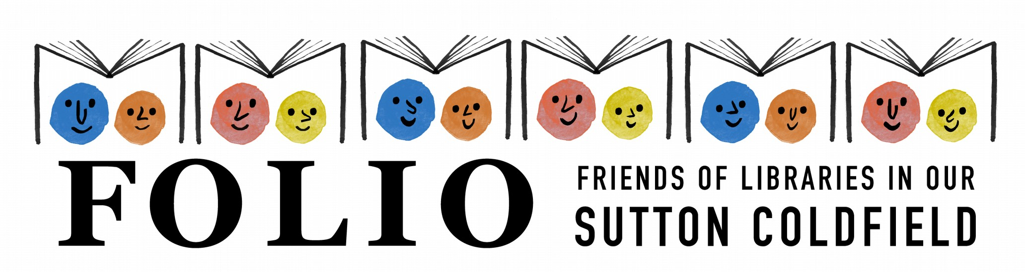

FOR IMMEDIATE RELEASE
21 January 2019

A new festival for children who love stories comes to Sutton Coldfield this spring!


FOLIO Sutton Coldfield has teamed up with the award- winning Busy Parents Network to create Sutton Coldfield BookFest on Saturday 2nd March - a day of drawing, poetry, animals and plenty of giggles.

Winnie the Witch illustrator Korky Paul will be at Sutton Coldfield Library, sketching the eccentric witch and her beloved cat Wilbur live.

Local author of more than 40 books Steven Smallman will be reading Bad Bunny, Cock-a-doodle-Poo! and Itchy Scritchy Scratchy Pants in an event bound to appeal to any mischievous pre-schooler. And both will take part in The Big Drawing Challenge (kindly sponsored by Sutton Coldfield Town Centre BID) - you choose a theme and see what these very different illustrators come up with!

Poetry slam champion A.F. Harrold will be both performing and holding a workshop for youngsters who want to create their own catchy rhymes.

And the lovely BB Taylor will bring along some furry friends for a very special storytelling session for animal lovers.
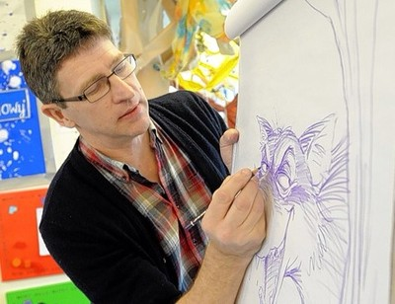

Steve Smallman said: “I’m so excited to be appearing at the Sutton Coldfield Bookfest!
A brand spanking new, sparkly, splendid book festival in a totally transformed, busy, buzzing library! Sutton Coldfield Library was saved from closure by the determination and commitment of a wonderful group of local people (FOLIO SUtton Coldfield) led by the indomitable Zoe Toft!
Now Zoe has teamed up with Sarah Mullen (Another force of nature!) to organise this festival which, after Sarah’s

phenomenal success with the Bournville Book Festival is sure to be amazing!So if you love libraries, if you’re bonkers about books or just want a brilliant, family day out, book your tickets now! It will be EPIC!”

A.F. Harrold said: “It’s rare these days to hear the words ‘Library’ and ‘Good News’ in the same sentence these days, but that’s exactly what we have here in Sutton Coldfield. It goes to show what can be achieved by the combination of bold campaigning and a listening council: not only can a library be maintained, but its place at the heart of the community can be bolstered, widened and lit brightly. It’s my honour to come and visit as part of the first Sutton Coldfield Bookfest and meet some of the regular borrowers, and hopefully encourage some new ones.”
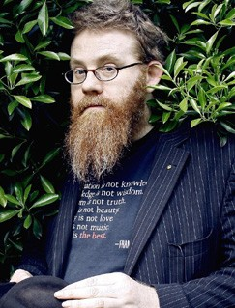

BB Taylor said: “I can't wait to be appearing at Bookfest in Sutton Coldfield with my cheeky characters this March. Sutton Coldfield library is very special to me and I love coming to visit. The work that has been
done to save this irreplaceable service to the community is amazing and i'm honoured to be back there. It's going to be so much fun!”

Zoe Toft, Chair of FOLIO Sutton Coldfield said: “Just days before World Book Day and Sutton Coldfield Library’s 82nd birthday (both on 7th March) we’re going to be hosting an amazing day in Sutton Coldfield Library, packed with stories, imagination, creativity and laughter – just about everything FOLIO wants to nurture in our local community through supporting our brilliant library. We can’t wait!

To be working with Sarah and Bournville BookFest is a dream come true. I first met Sarah at one of the first emergency meetings held not long after Sutton Coldfield library was earmarked for closure in 2016, and we’ve kept in touch since, inspiring and enthusing each other so to now be working together on something we both so passionately believe in is simply terrific. We’re both very grateful to Sutton Coldfield BID for supporting the day and we look forward to welcoming lots of families for an amazing day in the heart of their community.”

Sutton Coldfield BookFest is the new sister event of Bournville BookFest, which creates brilliant, affordable arts events for families to enjoy together.

Sutton Coldfield BookFest is going to be amazing, but don't just take our word for it - this is what families who came to last year's Bournville BookFest said about it:

"It's an outstanding event. Seeing the community inspired together really touches my heart." "BookFest encouraged my kids to try something new."
"Getting close up to authors and illustrators really inspires my children."
"It's an event for children, simply about BOOKS - what could be better? The volunteers and team were also incredibly friendly."

Comments made in feedback forms after Bournville BookFest 2018 via SurveyMonkey.

Tickets will be on sale from January 25th at: https://suttoncoldfieldbookfest.com/ where full details of the programme can also be found.

Printed programmes will be available from Sutton Coldfield, Mere Green, Boldmere and Walmley libraries.

You can keep up to date with Sutton Coldfield BookFest on facebook; https://www.facebook.com/SutColBookFest/

Notes for editors

- FOLIO Sutton Coldfield is a Registered Charity (No. 1175929, registered in England and Wales). We are a community group of Sutton Coldfield residents who want to see our public libraries not just survive, but thrive at the heart of our community.
http://foliosuttoncoldfield.org.uk/ https://www.facebook.com/FOLIOSuttonColdfield/ https://twitter.com/FOLIOsutcol

- Busy Parents Network organises fantastic family events including the award-winning Bournville BookFest. A not-for-profit community interest company, it aims to put inspiring high-quality arts events within reach of every family in Birmingham, by keeping ticket prices affordable and giving audiences a friendly welcome. Busy Parents Network is based at Bournville Hub, which it also runs for the community. For more information see www.bournvillebookfest.com.

