On Tuesday 22nd we had a Vesey Ward meeting in the Carpenters Arms. As is becoming usual, there were many residents in attendance, as per the photo. Cllr. Rob Pocock and Cllr. Kath Scott took turns at the Chair. Also, in attendance was Cllr. Jan Cairns.

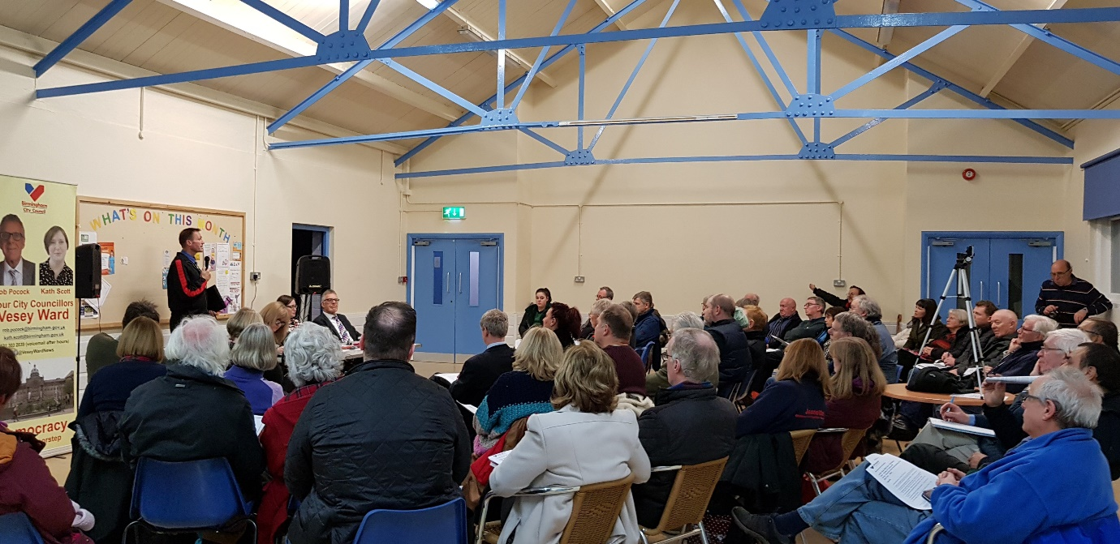

The speakers, in no particular order, were as follows:

Jeanette Nicholls from Boldmere St Michaels Church
Karl Randall Senior Engineer at Birmingham City Council
John Mole on how to bid for funds
John Porter on Sutton Park
Martin Pedley from Boldmere Traders
Dennis Kennedy from Sutton Community Games
Rosemary Quickende who spoke on behalf of John Lymn, Boldmere Futures Partnership
Lesley Bannister was the BCC admin officer taking the notes

Many questions were asked and answered. If you have an interest in what is going on in the ward and you have questions you would like answered, the next Vesey Ward meeting is on Tuesday, 19th March, 7 o’clock, Carpenters Arms.

