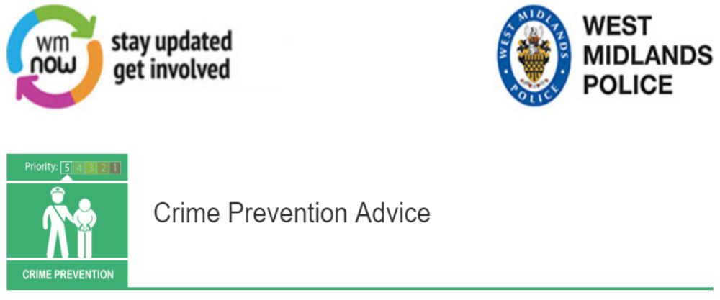
Up to now this year there have been 31 burglaries in the Vesey Ward. There were 14housebreaks in January and in February there was a significant drop with only 4burglaries reported in the whole Vesey ward. Unfortunately, the figure rose to 11 in March. Currently, this month we’ve only had two reported burglaries.
Please find some burglary prevention advice below -
Always use a full disklok when you are not using your vehicle, to place over your steering wheel. Although, these can be costly; they could save you a lot of hassle and inconvenience in the long-term. Furthermore, please ensure that your car keys are kept separately from your disklok key.
In about a third of burglaries, thieves gain access through an open window or door. Make sure doors and windows are kept locked when you go out, and close them even when you leave a room. Check the condition of door frames and glass panels to make sure they are secure. Make sure that the door barrels are anti-snap locks. For more information on these please visit www.securedbydesign.com.
When you are out, leave a light on to give the impression there is somebody at home. A light timer switch is fairly cheap to buy and can be easily fitted to operate radios and lights when you are out; giving burglars the impression that somebody is in. You can also buy a light which flickers like a TV light, so from the outside it looks as though you’re TV and lights have just turned on, which really would put people off approaching your property.
Don't forget - if you have an alarm on your house use it.
We hope this helps and by following our simple advice you can reduce your chances of becoming a victim of crime.
If you have seen or heard anything suspicious please call 101 or you can chat online on the West Midlands Police website.
Kind Regards
PCSO SATPAL SINGH 31410
Message Sent By
Satpal Singh (Police,PCSO,Birmingham East BEEA )

