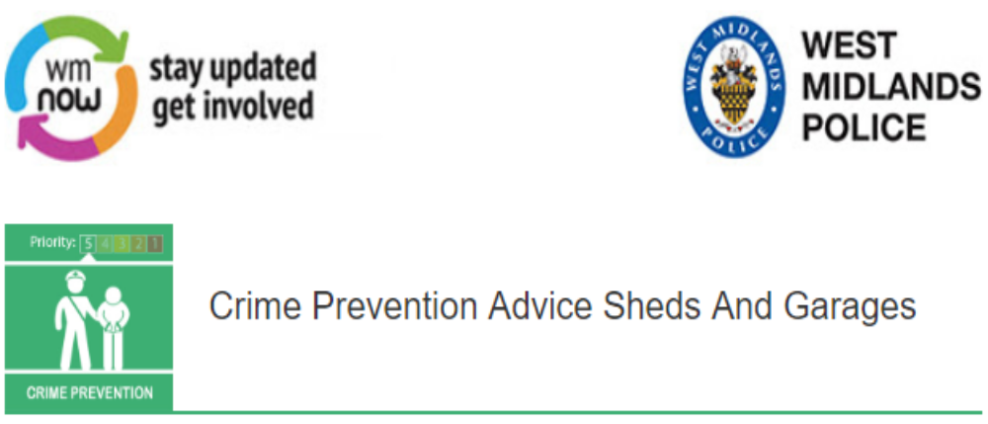
Spring is most definitely here!
The flowers are in bloom, the grass is green and growing, it's time for shed burglaries to start over again!
We have noticed an increase in Sheds and Garages being broken into and gardening equipment and bikes are being taken.
Here are a few tips to reduce the chance of you becoming a victim:-
LOCK your shed door with a mortice deadlock or padlock. Try to use locks with two large hasps, staples and padlocks.
STOP & LOCK tools in steel boxes fitted to the floor of your shed. Secure all garden items so they cannot be used by a burglar to break into your home.
SECURE ladders and expensive items such as lawnmowers & bikes, with a chain to an appropriate fixed point. A burglar would want to avoid a struggle to escape with an awkward load.
BLOCK out the windows of your shed, or if possible fit grilles.
PROTECT your shed contents by property marking them with your postcode – this is quick and easy to do. Remember to register your property for free on www.immobilise.co.uk
THINK about installing a battery-operated shed alarm. They can be relatively cheap and easy to install.
CHECK to see if any damage has occurred to your shed after the winter months and repair it.
Remember it is better to shed some pounds on security, than to let a burglar into your shed!
Message Sent By
Ian Willetts (Police, PCSO, Sutton Coldfield)

