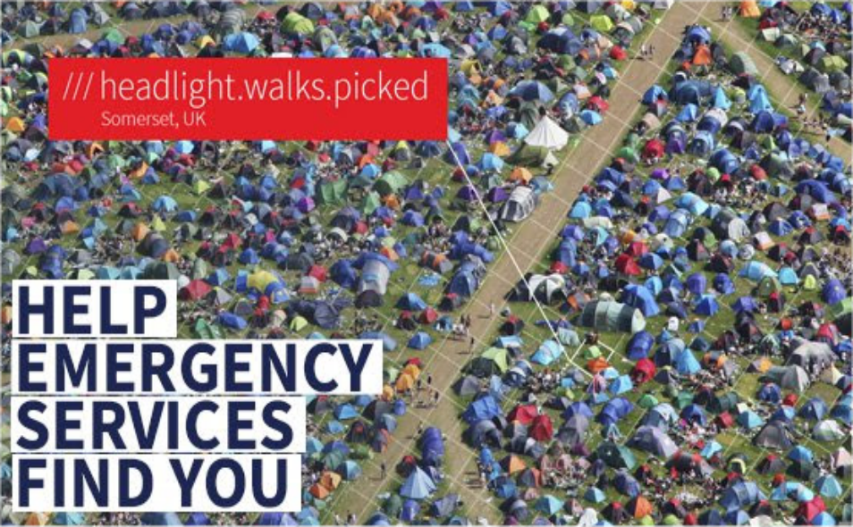

Hi Tony,

Summer’s a great time to be out and about, going to festivals and exploring the countryside. Unfortunately, these places can be difficult to describe in emergencies, which means that 999 call handlers have to deal with directions like “I can see a farm in the distance…” or “I’m near the white tent”. When every second counts, being able to describe where help is needed is crucial.
This week, emergency services across the UK are joining forces to raise awareness of what3words in their local communities. The message is simple: this summer, help emergency services find you by downloading the free what3words app and be prepared to give your 3 word address if needed.
This simple action could save lives this summer, and we’d love for you to be involved in sharing this message.
This is how you can help:
Share a post on your social media to reach friends, family and your wider community using the hashtag #Help999FindYou and tag @what3words.
- If sharing by email, Facebook etc., use this link: https://www.youtube.com/watch?v=EHS3tKpeUYw&feature=youtu.be
- Personal stories are always really powerful to share. If you’ve been in a situation where describing your location was difficult – maybe you lost your friends at a festival or were trying to find your way back to your family on the beach – share your story and tag @what3words and #Help999FindYou, we might feature your story on our feed

Thanks for your support!
The what3words Team

