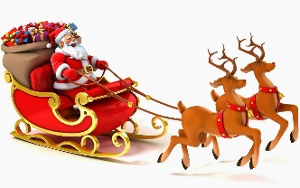
Boldmere Christmas Festival
Sunday 17th November 2pm to 7pm
with Christmas lights switch-on at 5:30pm

Come and join in the fun on Boldmere’s High Street as we look forward to Christmas and watch the Christmas lights being switched on by Buddy from Sutton Coldfield Community Games.

Real reindeer
Have your photograph taken with real reindeer with Santa’s sleigh next to Boldmere Bear in The Harvester carpark and then visit Santa at his grotto in Age Concern.
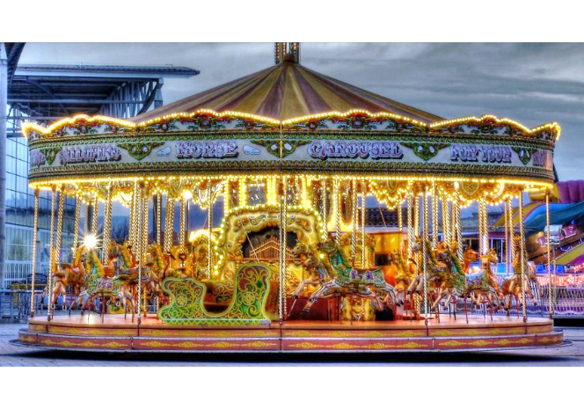
Children’s rides and entertainment
Enjoy children’s rides including a genuine Victorian galloping horses carousel, roundabout, cups and saucers, planes, bungee trampolines and Zorb Mania. There will also be circus performers performing in the crowds throughout the day.

Live music
Enjoy entertainment throughout the afternoon including our exciting line up of musicians and performers:
- 2:00 – First Request
- 2:45 – Ire-ish
- 3:30 – Celebration of Life
- 4:15 – Rhianna Keane
- 5:00 – Jack and Grandad with Andi the Puppet Man
- 5:30 – Turning on of Christmas Lights
- 5:35 – AlleyCats Pantomime Performance
- 6:15 – Rocket Café

Christmas market
Over 40 market stalls including cards and gifts.

Street food
Experience a variety of tastes of Street food including
- Pizza from The Handmade Pizza Company
- Vegan options from Tash n Dash
- Pork belly and pulled pork nachos from The Pork Society
- Chicken nuggets
- Churros from The Fabulous Food Guys
- 25 flavours of homemade brownies including vegan and dairy free options from Chocolate Treats
- Whippy ice-cream
- Sweet and savoury crepes from The Warwickshire Crepe Company
- Prosecco and Bubble Bar
- + all our regular food and drinks providers along the street

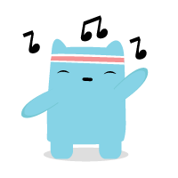
Christmas lights switch on at 5:30 by Buddy
Watch Buddy from Sutton Coldfield Community Games turn on Boldmere’s Christmas Lights with entertainment including Andi Markham the puppet man with Jack and Grandad and a mini Christmas pantomime and the Mayor of Sutton Coldfield wishing everyone Happy Christmas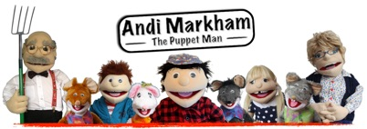

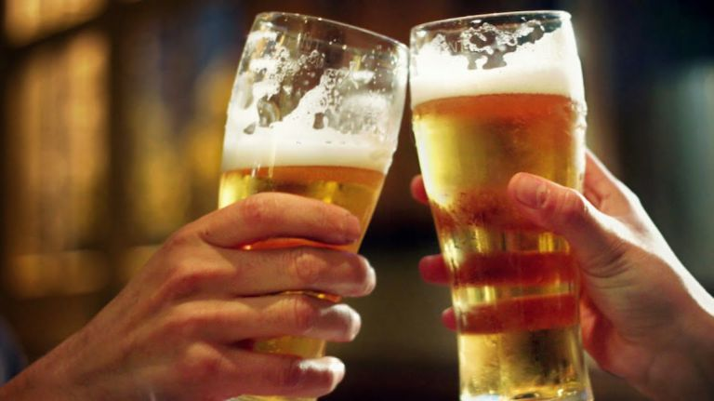
Enjoy having a drink afterwards?
We are grateful that all the pubs and bars along Boldmere’s High Street have agreed to operate a closed doors policy between 7pm and 9pm. This means that if you want to enjoy a drink after 7pm then you need to be in a pub or bar before 7pm. This will help to facilitate the clean-up operation at the end of the event. You can still book a table for food or turn up for food if a table is available.
www.boldmere.org/festivals
Suggested voluntary entry donation: £2 adults, £1 children, £5 family
Brought to you by Boldmere Futures Partnership, funded by Royal Sutton Coldfield Town Council

