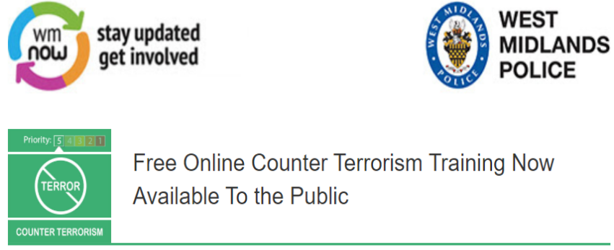

You can now sign up to an award-winning counter terrorism training course which has been made available to members of the public for the first time.
Devised by Counter Terrorism (CT) officers and security experts, the ACT Awareness eLearning package was previously only available to staff working in crowded places like shopping centres and entertainment venues.
Now Counter Terrorism Policing has decided to open up the training to anyone who wants to become a CT Citizen so they can learn how to spot the signs of suspicious behaviour and understand what to do in the event of a major incident.
The programme was originally devised in partnership with retail giant Marks & Spencer and participants needed to be signed up by their employers. However, the online learning is now available free of charge to anyone who wants to take part.
The decision to offer the training to the public was not made in response to the recent attack in London. However, the tragic events which took place just a few weeks ago, when two people lost their lives to terrorism, are a stark reminder of the ongoing threat and the need for vigilance.
ACT Awareness is made up of seven modules that take a few minutes each to complete. You can pause and re-join at any time. In total it takes just 45 minutes – so less than an hour of your time could help to prevent an attack or help save lives if one was to happen.
The course is hosted by online training specialists Highfield. To sign up and help protect the UK go to https://ct.highfieldelearning.com/
Every year thousands of reports from the public help police tackle the terrorist threat. If you see or hear something that doesn’t seem right, trust your instincts and ACT by reporting to police in confidence at https://act.campaign.gov.uk/ or by calling the Anti-Terrorist Hotline on 0800 789 321. Reporting won’t ruin lives, but it could save them. Action Counters Terrorism.
Please note, this account is not monitored 24/7 so if you need to report something please contact 999 in an emergency. If it is not an emergency please go to https://west-midlands.police.uk/ to visit our website and speak to an adviser on live chat between 8am – midnight (Monday – Sunday). Call 101 outside these hours.
Message Sent By
Amy Haycock (Police, Communications Manager, WMCTU)

