  
  

  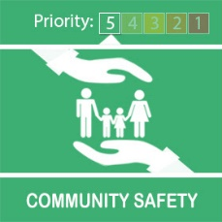
  Gov UK Scam Message - Be Aware

Dear Tony
Please be aware there are more scam text messages going around purporting to be from UKGOV:
Picture below shows actual message circulating!!
'You have been out of your house 3 times today, you are in breach of Government Guidelines, your £30 fine will be automatically added to your bill'.
‘We would like to inform you that you have been recorded as leaving your home on 3 occasions yesterday. A fine of £35 has been added to your gov.uk account. For further information please visit gov.uk/coronavirus-penalty-payment-tracking. Protect the NHS.
​​​​​​​
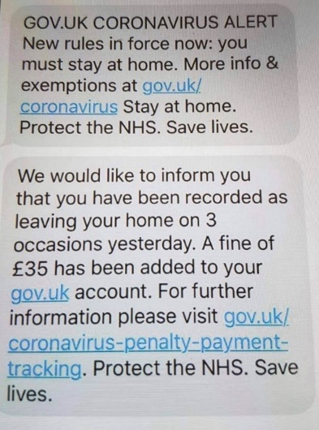
Kind regards
Message Sent By
Stefanie Sadler (Police, Engagement & Consultation officer, Birmingham Partnerships)

