
Our vision is to excel in all of our endeavours to meet the needs of older people and others in need. As those needs change during the current coronavirus pandemic, we are adapting our services to offer the best possible help, support and advice to individuals at this time. To keep people informed and updated during this worrying time, we will be publishing a regular newsletter to let you know about the
support and services that are available.

Support available from Age Concern Birmingham during the Coronavirus Outbreak
We are offering:

- A non-emergency telephone support line available Monday to
Saturday 9.30am to 4pm to provide advice and help to members of the com- munity in need

- Well-being calls to vulnerable citizens who need extra support and reassur- ance

- Free bags of essential food and non-food items delivered to those in need.

- A meal delivery service from the Communitea cafe in Sutton Coldfield, Erdington and Kingstanding.

- A shopping service for those unable to shop for food and other essential items

The above services can be accessed by calling 0121 362 3650 or emailing info@ageconcernbirmingham.org.uk

Sutton Coldfield Together
Royal Sutton Coldfield Town Council and Age Concern Birmingham are working together with the Sutton Coldfield Charitable Trust, and voluntary, community and faith organisations across Sutton Coldfield to ensure that local residents in need are able to access the support and information they need during these unprecedented times. A new Sutton Coldfield Together website has been created where help can be requested, and this also has the details of local organisations and groups offering support and services to those in need. You can access this at:
tiny.cc/suttontogether
We know that we have a caring community here in Sutton Coldfield and that many people will want to help out, and so the website also has a
facility for those wishing to get involved to register as a
volunteer, as well as advice on how to be a good neighbour in a way that keeps everyone safe.

In addition, the Sutton Coldfield Neighbourhood Network Scheme will be offering support to voluntary and community groups and faith organisations who may need advice and guidance together with
access to additional resources to enable them to deliver support and services to residents at this time and you can contact them
on NNS@ageconcernbirmingham.org.uk.

It is important that we all now focus our efforts in line with Government advice and this coordinated local response to give Sutton Coldfield the best chance of fighting COVID-19 together, to safeguard vulnerable peo- ple, avoid duplication and share only accurate and up to date information.



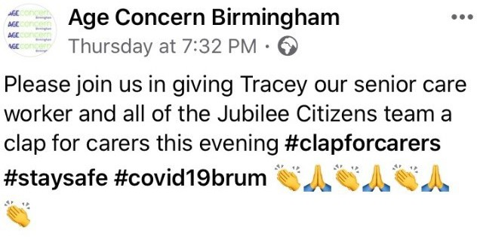


On Thursday evening, we were proud to join in with #clapforcarers, along with the rest of the nation. We want to say a huge thanks to the 70 plus members of our care and support team at Jubilee Citizens UK

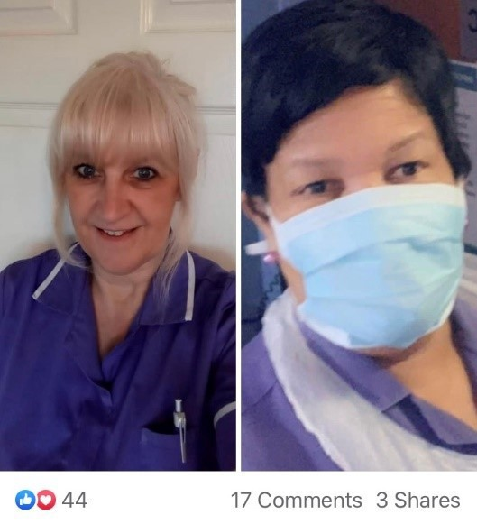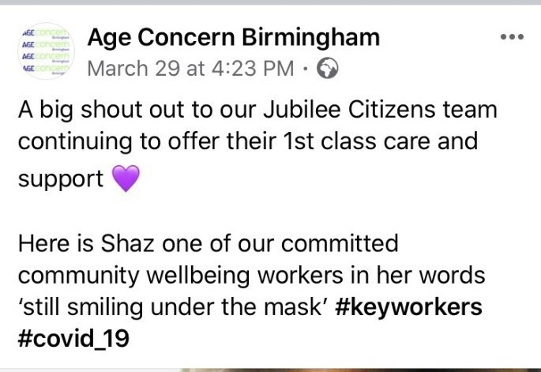



In response to the self isolation measures introduced by the Govern- ment, our aim is to ensure that older people and others who are vulnera- ble have a healthy meal that can be delivered to their home.

Cheese & potato pie £4 | Minced beef stew £4
Chicken & mushroom Curry £4 | Sausage, mash & peas £4
Mushroom stroganoff with rice £4 | Sweet & sour chicken with rice £4
Apple pie & custard £2 | Spotted dick & custard £2
Homemade rice pudding & | Homemade roast parsnip soup £2


Free delivery to Sutton Coldfield,
Kingstanding, Erdington and Four Oaks Meals can be delivered outside of these areas depending on amounts ordered but this will be subject to a delivery charge.
Please do give us a call to have a chat about your requirements as we want to help!

Call the café direct on 0121 630 2462
or email
communitea@ageconcernbirmingham.org.uk

Daycare and Wellbeing Services

The Wellbeing Service team have been making up bags of food and other essential items, which are then being delivered to people across Birmingham.

The kitchen at The Laurels centre in Mere Green has been busy providing extra meals for residents at the centre who are self-isolating and is also providing freshly cooked meals for residents from Wellington Court in Harborne. These are delivered daily along with a wellbeing check to ensure residents have everything they require. Meals are also being delivered to clients who are usually supported by family members who are self-isolating.

For those families who need emotional support at this challenging time, telephone conversations are taking place daily to provide reassurance and advice on issues such as ideas for stimulating activities that people can do with loved ones who living with dementia.


Other citizens have been supported to obtain blue badges, attendance allowance and pension credits, and our wellbeing co-ordinator has been keeping in contact with other vulnerable individuals to ensure that they have the help and support that
they need at this time.

Hawkesley Community Centre

Kings Norton South

What a busy two weeks we’ve had so far in lockdown. Although the Community Centre is shut for face to face activity, we are very much still open and available to support our community.
Over the past two weeks we have worked hard, trying to adapt to the ever changing guidelines. We have continued to provide as much support as possible though during these difficult times. Whether that be through calls, visits (at a safe distance of course!), signposting and referrals, or by providing food bags containing much needed essentials to as many people as possible.
It is lovely to see the community pull together in these difficult times and we would like to thank those local businesses that have helped us to achieve what we have been able to here in Hawkesley. A big thank you goes to Tony Geraghty’s Butchers in partnership with Andy Cartwright for their donation of Fresh Meat hampers and also Home Bargains in Northfield for allowing us to bulk buy essentials to go into our food bags.

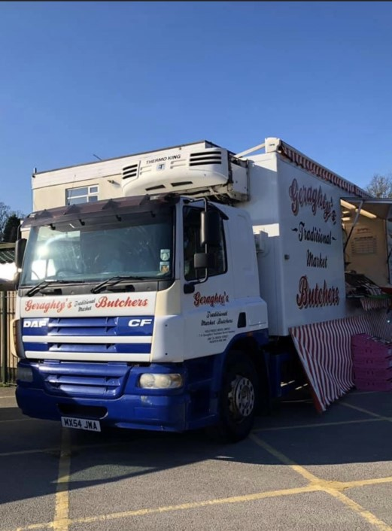
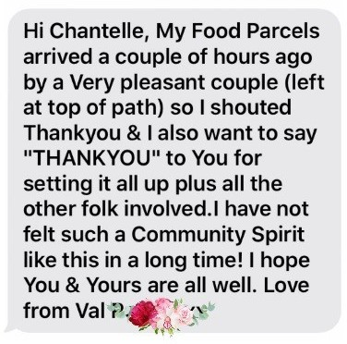
We would also like to say a big thank you to our community! Your feedback and thanks is very much appreciated and so lovely to hear and read.
If you or someone you know requires support of any kind please don’t hesitate to contact us on the details below:

Contact Gemma on: 0753 573 8116 g.oneill@ageconcernbirmingham.org.uk

Emergency Food Deliveries

The Communitea café has shifted its focus from providing affordable, healthy meals to all to being the operation centre for the distribution of bags containing essential food and non-food items to anyone in need.
The team worked with local supermarkets to purchase items in bulk and would especially like to say a big thank you to Tesco at New Oscott who jumped on board and helped us out.

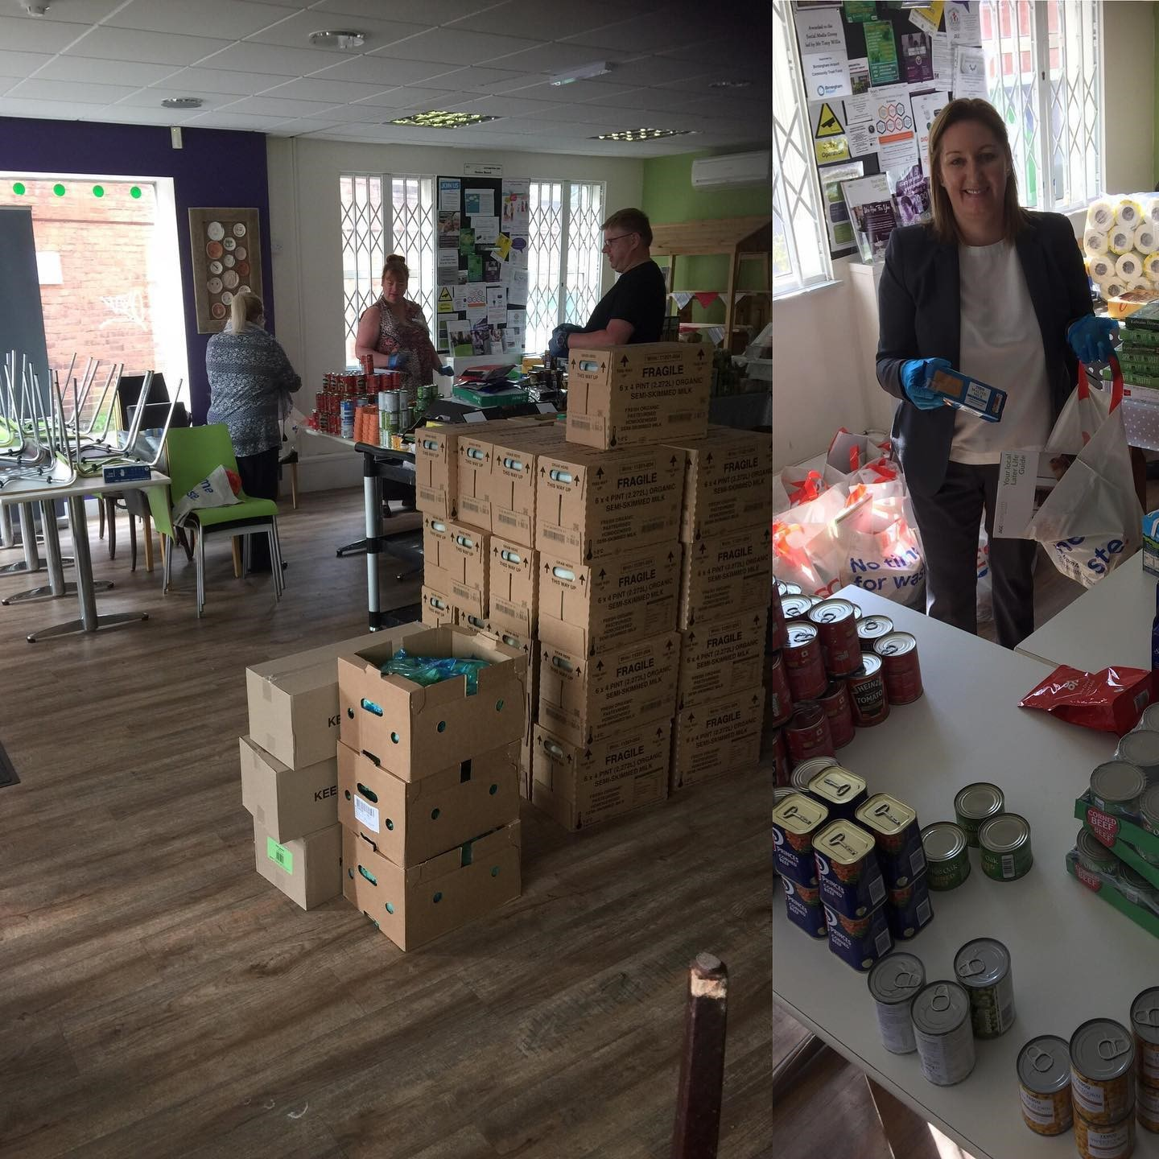
Bags were packed, cars filled and a team of five have been distributing bags across Sutton Coldfield and
Birmingham every day, reaching those who would otherwise have struggled to get by.

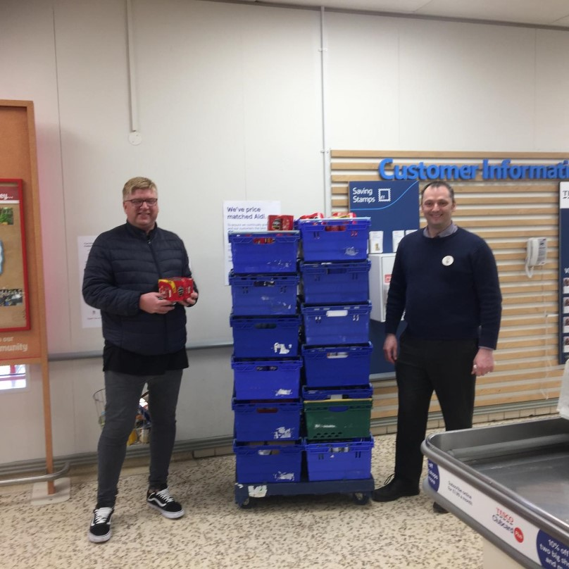


The essential bags delivered to residents of Sutton Coldfield have been funded by Royal Sutton
Coldfield Town Council’s Community Grant Programme


Birmingham Carers Hub
delivered in partnership with
Forward Carers

We have all been affected by the rapid escalation of the Covid-19 virus during the past month, but none more so than disabled people and people with long-term health problems, older people and of course carers.
It is so very important that everyone cuts down on social contact and adheres to government and NHS advice on self-isolation and staying at home. For carers this is a dilemma because they are torn between looking after their loved ones in the usual way whilst also protecting them from the virus being brought into the home.
If the carer and the cared-for person live in the same house, then people can at least isolate together, though many carers will still be feeling anxious about the what-ifs. What if my relative becomes ill and has to go to hospital? What if I be- come affected by the virus and cannot fulfil my caring role?
For a disabled or older person living alone, the same questions apply but with additional issues. What if the cared-for person tests positive for Covid-19, who will provide them with care? How can I provide support without increasing the risk of taking the virus into someone’s home?
Like so many organisations, from the NHS down to the local food bank, from emergency services to local charities, Birmingham Carers Hub have adapted to the situation very quickly. Our first priority was to facilitate home working for our team of advisors, making sure we have the right communication equipment to enable carers to contact us and for our staff to continue providing help and support.
The Carers Hub helpline is open between 9.30am and 4.30pm from Monday to Fri- day and we can make appointments to talk to carers at other times if this is difficult. We are endeavouring to pick up calls straight away between these times but if your call is diverted to the voice mail, please leave us a message and we will get back to you as soon as we can.
We are contacting carers on our database to offer a safe and well chat and a quick assessment of your situation and we can offer support and/or refer you to help from the network of services which are now springing into action.

If you need advice and support, please call us on our usual number on 0333006 9711 or email us at info@birminghamcarershub.org.uk

Heritage Project

A Project Supported By

For millions of older people in the UK the current health crisis, caused by the Covid-19 virus, is creating feelings of anxiety, uncertainty and isolation. Keeping safe and well means staying indoors and minimising contact with neighbours, carers and loved ones but avoiding close contact with other people doesn’t mean that you have to be bored or feel forgotten. As people
get older they often say things like “it’s about time I wrote down my life story” or their children and grandchildren will say “if only Nan, Granny or Granddad would record their precious memories”.
But most of us reach older age without finding the time to commit pen to paper or to sit down at the computer keyboard and simply type away.
You may have fascinating recollections of your school days, your armed service, employment, sport, family life or historic events and younger generations are always interested to learn what life was like 60, 70 or 80 years ago and to hear those personal stories, the sad ones alongside the happy ones.
At Age Concern Birmingham we are running a memory based project which is funded by the Heritage Fund. We are collecting memories and stories from older people in Birmingham and the wider West Midlands, many of which will be included in a book to be published later this year or published on our blog. Because of the Covid-19 crisis we have had to postpone our events and face-to-face interviews with local people. So we’re looking at delivering our project another way. We don’t want to stop our project when we know that there are thousands of older people in the city sitting at home feeling bored and isolated but who could still contribute stories.
Please join in with our memory writing-and-recording project today. Whether you start off with a few bullet-points or dive straight into your memoirs, write it, type it, tape it or dictate it, dig out your old documents and photographs for scanning, we welcome it all for our project!
Please send your memories to:
Peter Millington at Age Concern Birmingham, 76-78 Boldmere Road,
Birmingham B73 5TJ or
email peter.millington@birminghamcarershub.org.uk

Ageing Better in Birmingham City Wide Hub & Carers Hub

All groups have of course been postponed due to the current coronavirus pandemic and so the
Ageing Better hubs have been having regular
update meeting via Zoom to explore ways in which group members can continue to have social connections, in line with the current social
distancing guidelines.
The hubs are also keeping in touch with groups over the phone and have found that many of them are supporting their members with help to get shopping and other essentials.

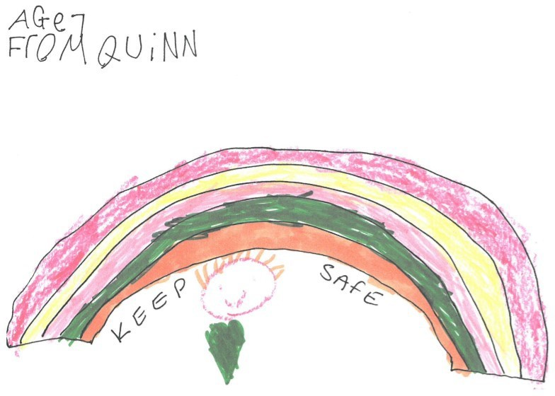
It’s fantastic to see so many local initiatives taking place in neighbourhoods across the city at this time and one of our favourites has been the many rainbows which have been appearing in windows to spread cheer and share a message of hope in our communities. We are so pleased that people have started sending rainbows into our Head Office at Boldmere and are looking forward to seeing our very own Age Concern Birmingham window of rainbows!

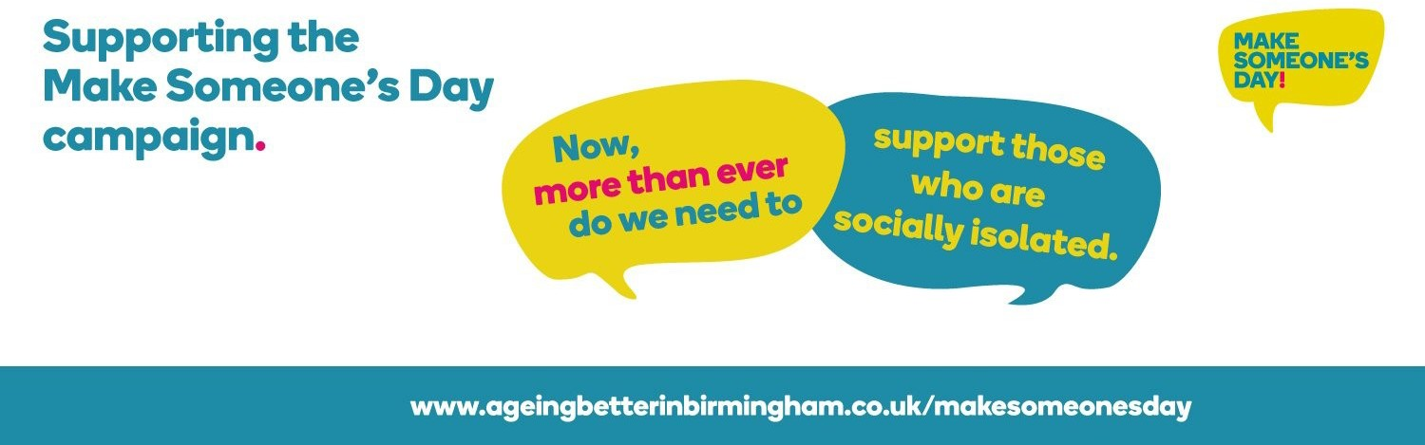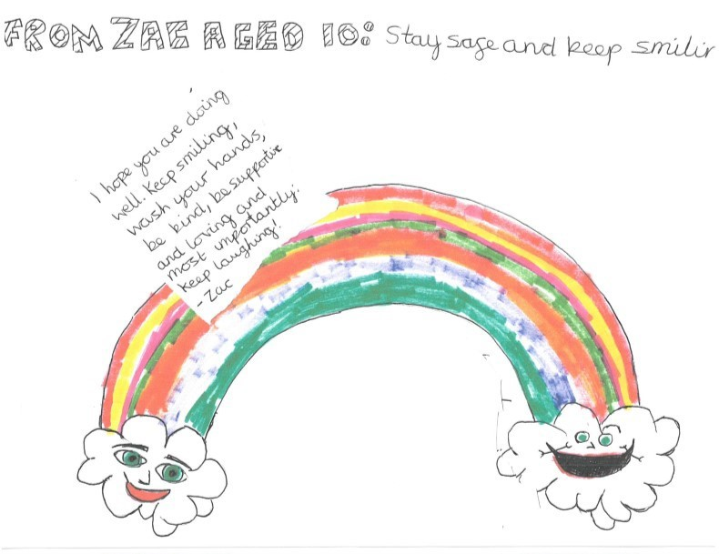

Fraud Awareness


With the challenge that the coronavirus pandemic is presenting to everybody, but in particular for older people, it is clear that protection against scams and fraud is now more important than ever. We have already seen evidence that ‘scammers’ have started to exploit the situation and so Age Concern Birming-
ham have developed a simple toolkit to share advice and guidance around fraud awareness.

As part of this, we want to share some key messages around this, as follows:

Spot It
Be alert to the warning signs:
- pushy and persuasive salesmen
- offers that have restricted time offers
- are you being asked for personal information?
- being asked for large amounts of money up front
- are they based overseas? does their telephone number work? Remember:
- Always take your time, don’t be rushed into making a commitment &
becoming a victim of fraud and get a second opinion from friends, family or neighbours.

- Fraud can take many forms, some of them sophisticated. Do not feel foolish if you fall victim to it. It can happen to anyone but it’s important you report the incident to help stop it happening again or to someone else.

- Never give your details (name, address, bank details or PIN) to any- one.

- You don’t have to pay money to get money – if you’re asked to, it’s probably a scam!

Fraud Awareness

Practical tips and advice:
- Be suspicious of pushy/persuasive salesmen and requests for money up-front
- If you cannot contact them without them contacting you, do not proceed
- If you receive an unsolicited call and/or they claim to be from your bank or the police and request your PIN or personal information shut down the communications & contact Action Fraud (see contact details below)
- Never share your PIN with anyone – the only times you should use your PIN is at a cash machine or at shop’s chip and PIN machine.
- Opt out of unsolicited calls by registering with the Telephone Prefer- ence Service on 0345 070 0707
- Never send money to anyone you don’t know or pay fees, however small, to claim prizes or lottery winnings.
- Remove your name from direct mailing lists by calling MPS on 0207 291 3310
- Never let an unknown person in to your house, always ask for ID.
- The virtual world is like the real world, you still need to take your
time, think twice and make necessary checks

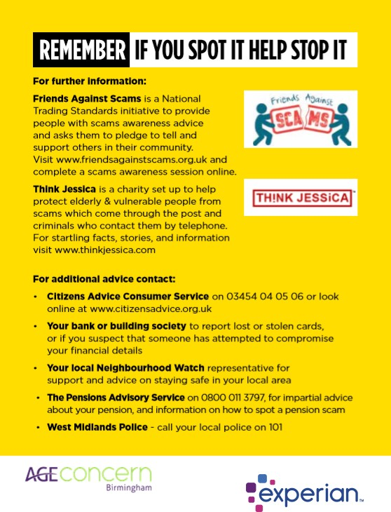

Legal Services

COVID-19 (Coronavirus) - Important Information

Our legal services are still available please see the following update from our legal partner McClure solicitors:-

Due to the outbreak of COVID-19 (Coronavirus) there are now severe restrictions on the movement and interaction of people as a means to curb the spread of the disease. As a firm and a business we have been following Government guidelines carefully and will continue to do so. The safety and wellbeing of our clients and of our staff remains our primary concern.

With this in mind we implemented changes from Friday 20th March 2020 in the way we conduct our client appointments – both to take client instructions and also how we organise the signing of client legal documents.

We will (and have been for a couple of weeks where applicable) be switching all current face to face appointments, regardless of whether these were to be con- ducted in one of our offices, at a client’s home or at one of our Charity Partner Will Clinics to telephone or video appointments.

If clients wish to have their appointment as a video appointment we will be able to conduct these via a choice of either Skype, WhatsApp or Zoom.

We appreciate that some clients’ first inclination may be to postpone or re- arrange their existing appointment. We would urge them not to do so. Making sure that estate planning is in order remains an important issue for clients, per- haps more so than ever.

We are committed and prepared to support you as always in achieving this.
Please call 0121 362 3650 to book an appointment or email
info@ageconcernbirmingham.org.uk

Good News

“Thank you so much for my shopping that has just been delivered
- much appreciated”
“What a lovely thing you’re doing xx”

“The Communitea café meals and the shopping service are fantastic job we are doing and everyone is lovely”
“Thank you for caring”

“You are all so friendly there. I want to help out in some way!”
“Thank you for taking the time to call me”

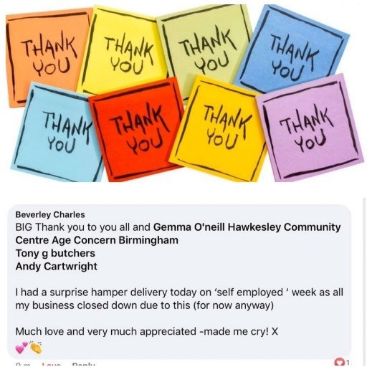

Donate
15

Please help Age Concern Birmingham to provide much needed support to isolated and vulnerable people by
making a donation. Each bag of essential items we are providing costs around £12, but please do give whatever you can to help us make a difference to as many people as possible during this difficult
time. You can make a donation to Age
Concern Birmingham via our website as follows:
http://www.ageconcernbirmingham.org.uk/
donate/

Volunteer at Age Concern Birmingham

We are looking for volunteers to help us deliver our much needed support and services to those in need. If you can spare a couple of hours a week, please contact our Volunteer Co-ordinator Claire Beattie to have a chat about how you might be able to help.

Claire can be contacted on 07930 354885 or you can email

c.beattie@ageconcernbirmingham.org.uk




Further information and resources

For the most up-to-date advice and guidance on the coronavirus pandemic visit: https://www.gov.uk/coronavirus

For the latest health information on https://www.nhs.uk/conditions/
coronavirus-covid-19/

To report fraud and cyber crime visit https://www.actionfraud.police.uk/ or call 0300 123 2040

If you are struggling with your mental health you can speak to someone from Birmingham Mind. Their Helpline is open 7 days a week from 9 am - 11 pm. Tel: 0121 262 3555. Or email help@birminghammind.org.

Follow us:
www.ageconcernbirmingham.org.uk Facebook: @ageconcernbirminghamUK Twitter: @ACBirmingham1
Instagram: #ageconcernbirmingham
To receive an electronic copy of this newsletter please email us at
info@ageconcernbirmingham.org.uk


