
Our vision is to excel in all of our endeavours to meet the needs of older people and others in need. As those needs change during the current coronavirus pandemic, we are adapting our services to offer the best possible help, support and advice to individuals at this time. To keep people informed and updated during this worrying time, we will be publishing a regular newsletter to let you know about the
support and services that are available.

Support available from Age Concern Birmingham during the Coronavirus Outbreak

We are offering:

- A non-emergency telephone support line available Monday to Saturday, 9.30am to 4pm to provide advice and help to members of the community in need

- Well-being calls to vulnerable citizens who need extra support and reassurance

- Free bags of essential food and non-food items delivered to those in need.

- A meal delivery service from the Communitea cafe in Sutton Coldfield, Erdington and Kingstanding.

- A shopping service for those unable to shop for food and other essential items

The above services can be accessed by calling 0121 362 3650 or emailing info@ageconcernbirmingham.org.uk

Sutton Coldfield Together
Royal Sutton Coldfield Town Council and Age Concern Birmingham are working together with the Sutton Coldfield Charitable Trust, and voluntary, community and faith organisations across Sutton Coldfield to ensure that local residents in need are able to access the support and information they need during these unprecedented times. A new Sutton Coldfield Together website has been created where help can be requested, and this also has the details of local organisations and groups offering support and services to those in need. You can access this at:
tiny.cc/suttontogether

We know that we have a caring community here in Sutton Coldfield and that many people will want to help out, and so the website also has a facility for those wishing to get involved to register as a volunteer, as well as advice on how to be a good neighbour in a way that keeps everyone safe.

In addition, the Sutton Coldfield Neighbourhood Network Scheme will be offering support to voluntary and community groups and faith organisations who may need advice and guidance together with access to additional resources to enable them to deliver support and services to residents at this time and you can contact them on NNS@ageconcernbirmingham.org.uk.

It is important that we all now focus our efforts in line with Government advice and this coordinated local response to give Sutton Coldfield the best chance of fighting COVID-19 together, to safeguard vulnerable people, avoid duplication and share only accurate and up to date information.



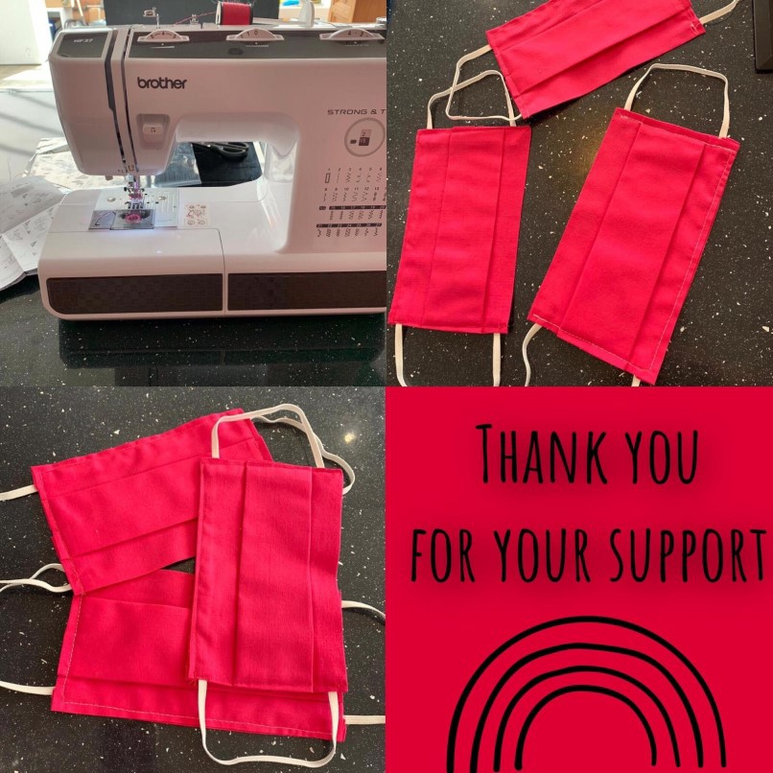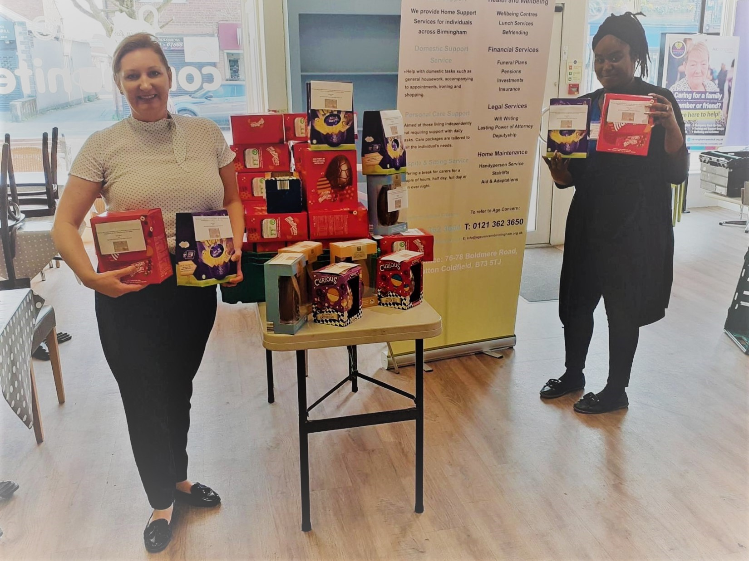

Another fantastic week of care provided by our care and support, wellbeing and domestic workers.

Our CEO Becky Bews & acting service manager
Tiyana Needham preparing Easter eggs donated by
Aldi at Kingstanding
which went out to all of our
fantastic key workers who were working over the
Easter period.

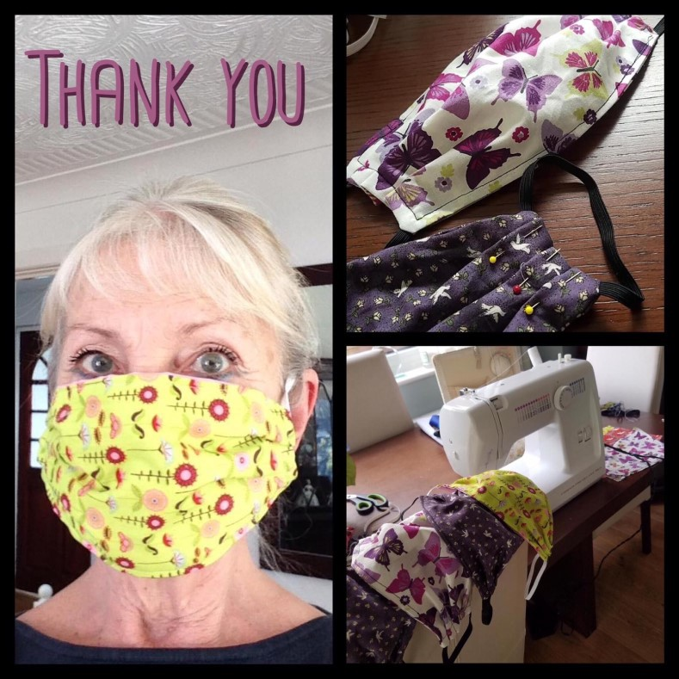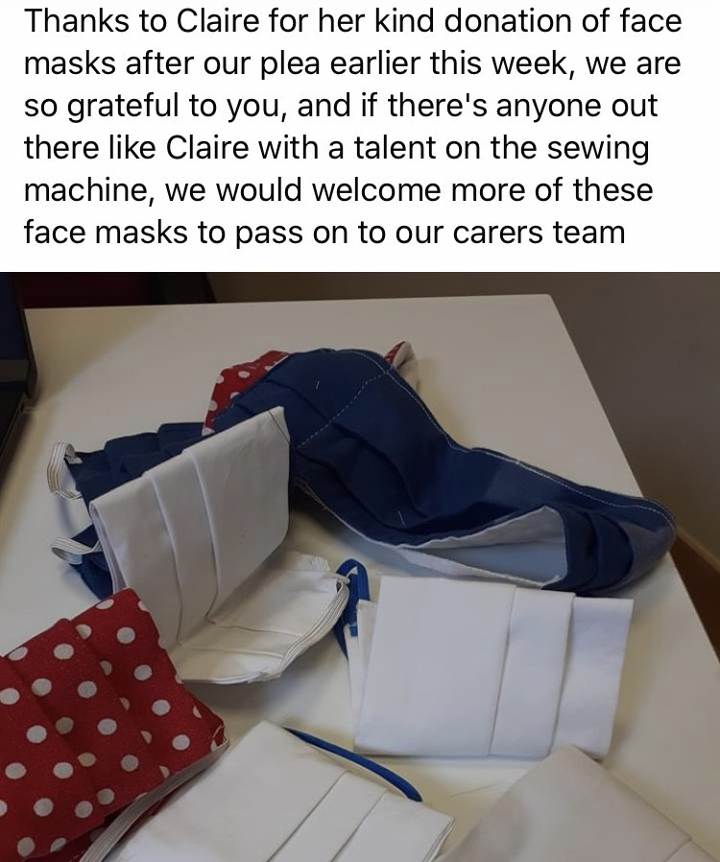
Providing adequate PPE for our workers is proving challenging particularly masks, and we are constantly trying to source
them.
We have had some masks made and
donated to us.
Whilst these are not a barrier to breathing germs they do prevent touching of nose and mouth.
A huge thank you to Gail, Diane, June and Claire; they are very much appreciated



In response to the self isolation measures introduced by the Government, our aim is to ensure that older people and others who are vulnerable have a healthy meal that can be delivered to their home.

Cheese and potato pie £4 | Gammon with mash & parsley sauce £4
Chicken & Vegetable Pie with roast potatoes £4 | Sausage, mash & peas £4
Braised steak & mash £4 | Sweet & sour chicken with rice £4
Apple pie & custard £2 | Spotted dick & custard £2
Homemade rice pudding &  summer fruit curd £2 | Bread & Butter Pudding with custard  £2

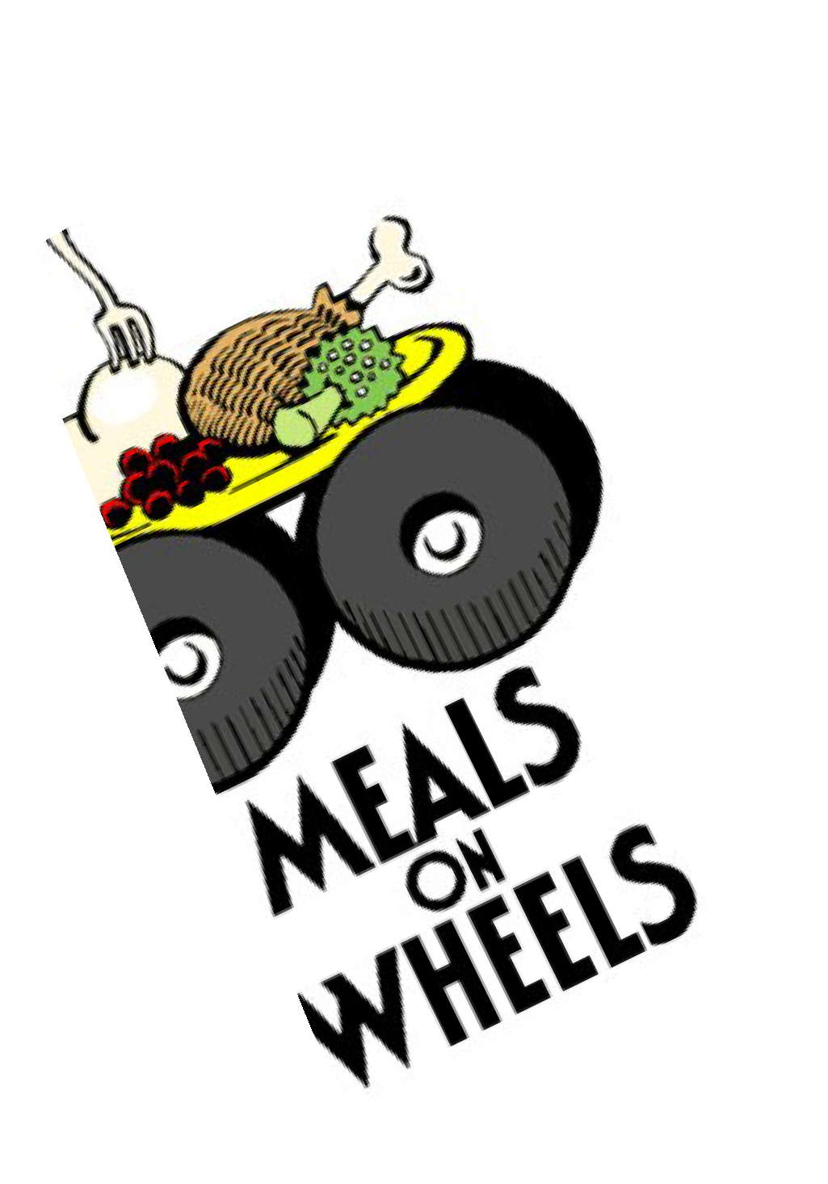
Free delivery to Sutton Coldfield,
Kingstanding, Erdington and Four Oaks Meals can be delivered outside of these areas depending on amounts ordered but this will be
subject to a delivery charge.
Please do give us a call to have a chat about your requirements as we want to help!

Call the café direct on 0121 630 2462
or email
communitea@ageconcernbirmingham.org.uk

Daycare and Wellbeing Services
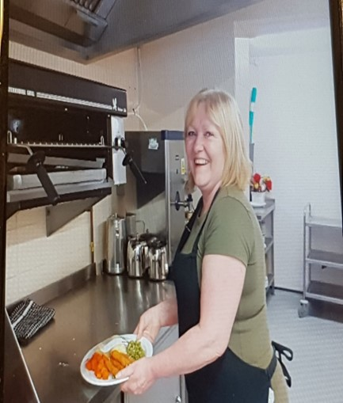
From Tuesday this week we have temporarily changed the kitchen service from The Laurels. Sharon is continuing to provide freshly cooked meals for the residents at The Laurels but with the temporary move of the kitchen to the Communitea Café in Boldmere. The meals will be delivered to the residents with wellbeing checks continuing also. Sharon will continue to provide meals for Wellington Court residents with the additional service to clients who are usually supported by family members who are self-isolating.

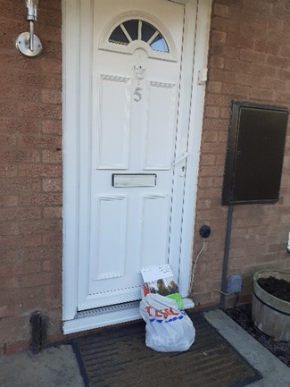
Food bags are continually being delivered to those in need across Birmingham. This has been welcomed by clients who are
self-isolating following the government’s guidelines and have little or no support. We provide food bags and information in our later life booklet.
One client told us:
“This is a lifeline and it’s great to see someone to speak to at a safe distance, telling us to stay safe and we will be clapping for you all on Thursday.”

Hawkesley Community Centre
Kings Norton South

Another busy week and although the Community Centre remains shut for face to face activity, we are very much still available to support our local Community.

We have been working hard to continue to provide as much support as possible during these difficult times, whether that be through calls,
signposting and referrals, or by providing food bags containing much needed essentials to as many people as possible. It was fantastic to receive a letter from the Lord Mayor of Birmingham thanking us for all of our efforts and you can see the letter on our Good News page.

As ever, we would also like to say a big thank you to our community! Your support, feedback and thanks is always appreciated so please do keep in touch!


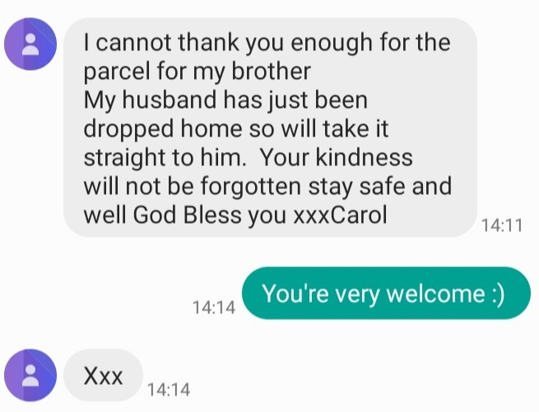

If you or someone you know requires support of any kind please don’t hesitate to contact us on the details below:

Contact Gemma on: 07535 738 116 g.oneill@ageconcernbirmingham.org.uk

Emergency Food Deliveries

The Communitea café shifted its focus from providing affordable, healthy meals to all to being the operational centre for the distribution of bags containing essential food and non-food items to anyone in need. The
team worked with local supermarkets to purchase items in bulk and would especially like to say a big thank you to Tesco at New Oscott who jumped on board and helped us out.

Bags were packed, cars filled and a team of five have been distributing bags across Sutton Coldfield and Birmingham every day, reaching those who would otherwise have struggled to get by.
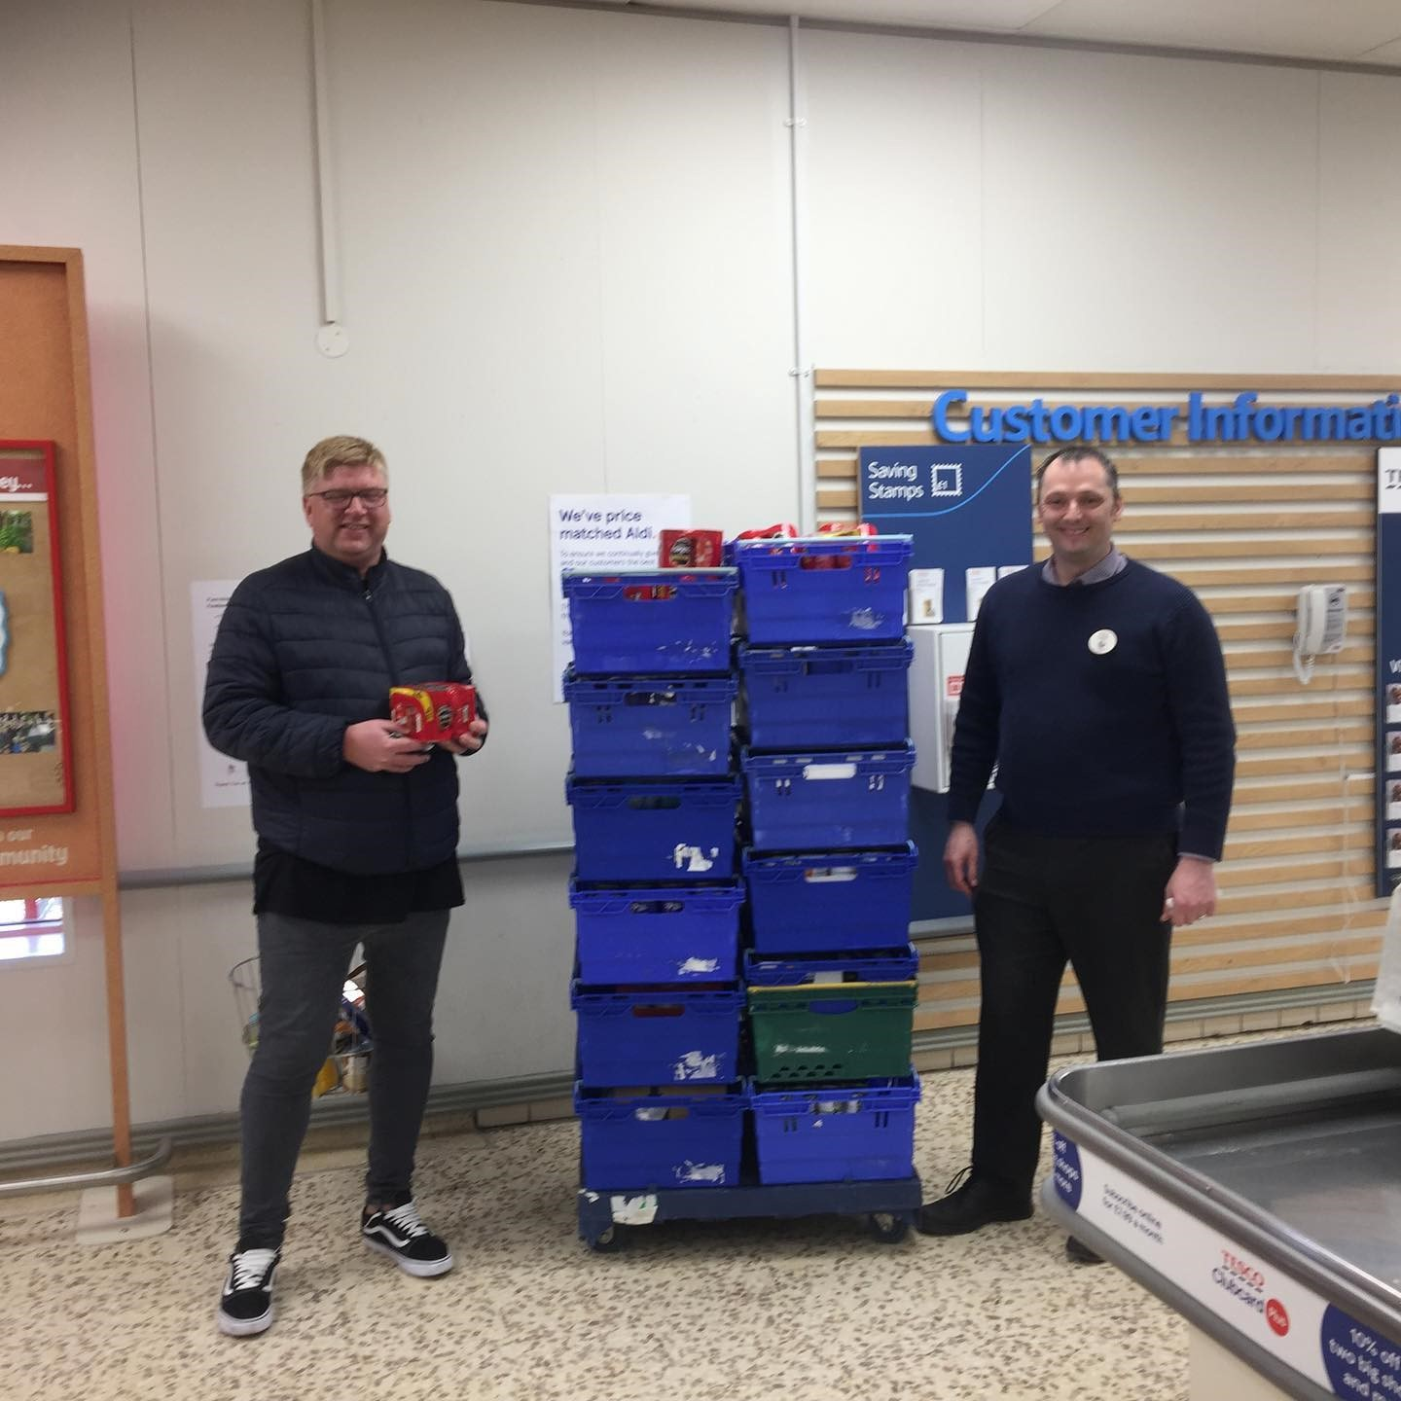
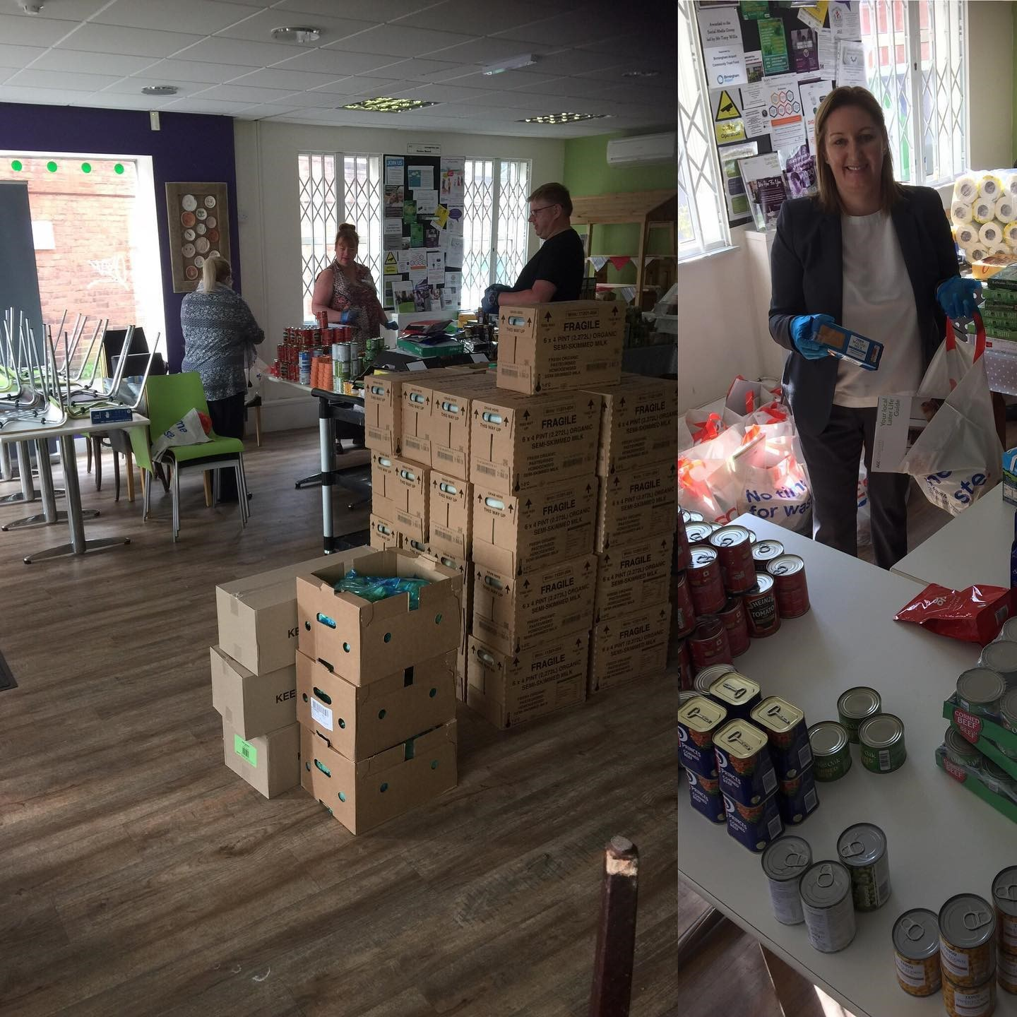

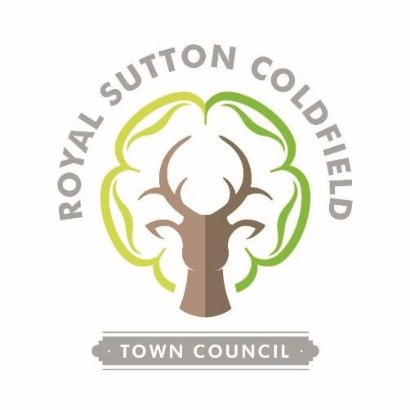
The essential bags delivered to residents of Sutton Coldfield have been funded by Royal Sutton Coldfield Town Council’s Community Grant Programme.


Birmingham Carers Hub
delivered in partnership with Forward Carers

We have all been affected by the rapid escalation of the Covid-19 virus during the past month, but none more so than disabled people and people with long-term health problems, older people and of course carers.
It is so very important that everyone cuts down on social contact and adheres to government and NHS advice on self-isolation and staying at home. For carers this is a dilemma because they are torn between looking after their loved ones in the usual way whilst also protecting them from the virus being brought into the home.
If the carer and the cared-for person live in the same house, then people can at least isolate together, though many carers will still be feeling anxious about the what-ifs. What if my relative becomes ill and has to go to hospital? What if I be- come affected by the virus and cannot fulfil my caring role?
For a disabled or older person living alone, the same questions apply but with addi- tional issues. What if the cared-for person tests positive for Covid-19, who will pro- vide them with care? How can I provide support without increasing the risk of tak- ing the virus into someone’s home?
Like so many organisations, from the NHS down to the local food bank, from emer- gency services to local charities, Birmingham Carers Hub have adapted to the situ- ation very quickly. Our first priority was to facilitate home working for our team of advisors, making sure we have the right communication equipment to enable carers to contact us and for our staff to continue providing help and support.
We are contacting carers on our database to offer a safe and well chat and a quick assessment of your situation and we can offer support and/or refer you to help from the network of services which are now springing into action.

Our advisors are at the end of the phone to take your calls about caring issues and concerns between 9.30 & 4.30 Monday to Friday. We can also arrange to talk to carers at other times. If you live in Birmingham and you'd like to be registered as a carer, please get in touch. Call us on 0333 006 9711 or email us at info@birminghamcarershub.org.uk

Heritage Project

A Project Supported By

For millions of older people in the UK the current health crisis, caused by the Covid-19 virus, is creating feelings of anxiety, uncertainty and isolation. Keeping safe and well means staying in- doors and minimising contact with neighbours, carers and loved ones but avoiding close contact with other people doesn’t mean that you have to be bored or feel forgotten. As people get older they often say things like “it’s about time I wrote down my life story” or their children and grand- children will say “if only Nan, Granny or Granddad would record their precious memories”. But most of us reach older age without finding the time to commit pen to paper or to sit down at the computer keyboard and simply type away.
You may have fascinating recollections of your school days, your armed service, employment, sport, family life or historic events and younger generations are always interested to learn what life was like 60, 70 or 80 years ago and to hear those personal stories, the sad ones alongside the happy ones.
At Age Concern Birmingham (ACB) we are running a memory based project which is funded by
the Heritage Fund. We are collecting memories and stories from older people in Birmingham and the wider West Midlands, many of which will be included in a book to be published later this year or published on our blog. Because of the Covid-19 crisis we have had to postpone our events and face-to-face interviews with local people. So we’re looking at delivering our project another way. We don’t want to stop our project when we know that there are thousands of older people in the city sitting at home feeling bored and isolated but who could still contribute stories.
Please join in with our memory writing-and-recording project today. Whether you start off with a few bullet-points or dive straight into your memoirs, write it, type it, tape it or dictate it, dig out your old documents and photographs for scanning, we welcome it all for our project!
Please send your memories to:
Peter Millington at Age Concern Birmingham, 76-78 Boldmere Road,
Birmingham B73 5TJ or
email peter.millington@birminghamcarershub.org.uk

Ageing Better in Birmingham City Wide Hub & Carers Hub

Do you want to help and reduce social isolation for Brummies over 50 during the coronavirus pandemic?

Not sure how to get your idea up and running?

Get in touch with Ageing Better in Birmingham!
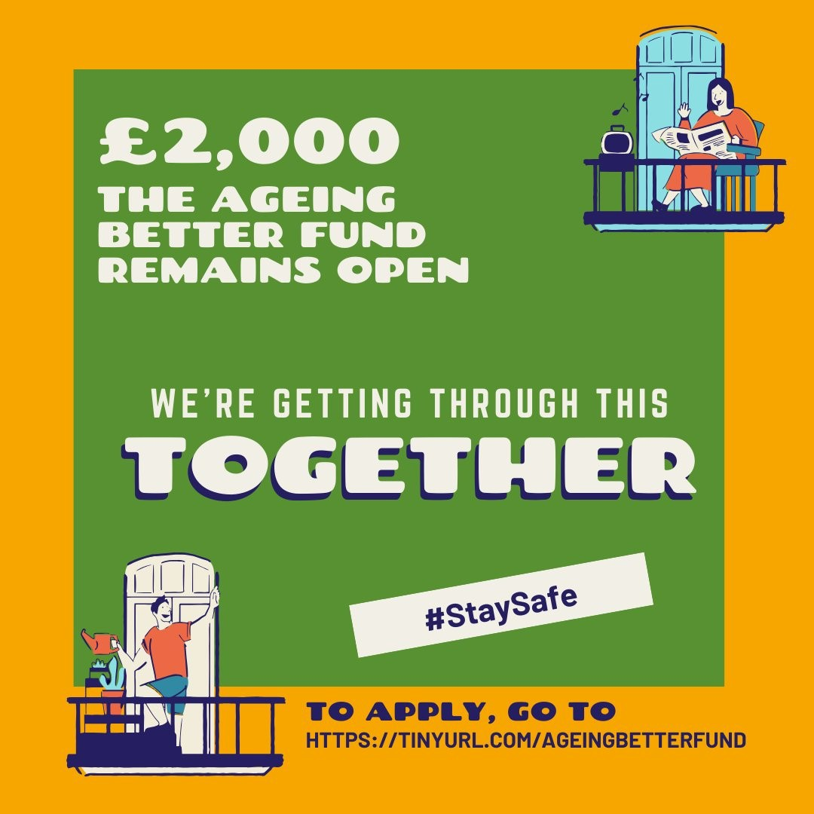

Fraud Awareness

With the challenge that the coronavirus pandemic is presenting to everybody, but in particular for older people, it is clear that protection against scams and fraud is now more important than ever. We have already seen evidence that ‘scammers’ have started to exploit the situation and so Age Concern Birmingham have developed a simple toolkit to share advice and guidance around fraud awareness.

As part of this, we want to share some key messages around this, as follows:

Spot It
Be alert to the warning signs:
- pushy and persuasive salesmen
- offers that have restricted time offers
- are you being asked for personal information?
- being asked for large amounts of money up front
- are they based overseas? does their telephone number work?

Remember
- Always take your time, don’t be rushed into making a commitment & becoming a victim of fraud and get a second opinion from friends, family or neighbours.

- Fraud can take many forms, some of them sophisticated. Do not feel foolish if you fall victim to it. It can happen to anyone but it’s important you report the incident to help stop it happening again or to someone else.

- Never give your details (name, address, bank details or PIN) to
anyone.

- You don’t have to pay money to get money – if you’re asked to, it’s probably a scam!

Fraud Awareness

Practical tips and advice:
- Be suspicious of pushy/persuasive salesmen and requests for money up-front
- If you cannot contact them without them contacting you, do not proceed
- If you receive an unsolicited call and/or they claim to be from your bank or the police and request your PIN or personal information shut down the communications & contact Action Fraud (see contact details below)
- Never share your PIN with anyone – the only times you should use your PIN is at a cash machine or at shop’s chip and PIN machine.
- Opt out of unsolicited calls by registering with the Telephone Prefer- ence Service on 0345 070 0707
- Never send money to anyone you don’t know or pay fees, however small, to claim prizes or lottery winnings.
- Remove your name from direct mailing lists by calling MPS on 0207 291 3310
- Never let an unknown person in to your house, always ask for ID.
- The virtual world is like the real world, you still need to take your
time, think twice and make necessary checks

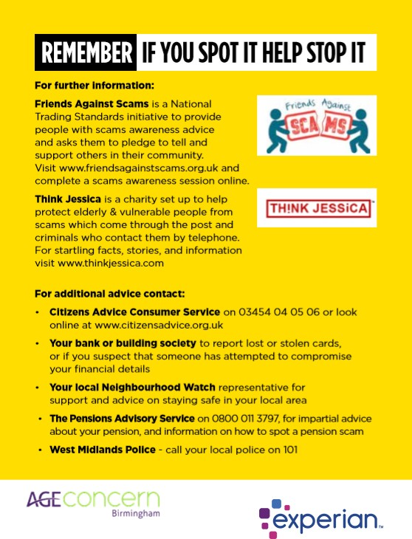

Good News Stories

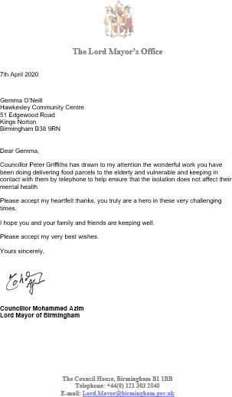


Good News Stories

We were pleased to be able to donate 50 large tins of powdered baby milk to local services supporting mothers and babies in Birmingham.
Theresa Millington, a mental health nurse on the Mother and Baby team of Birmingham and Solihull Mental Health NHS Foundation Trust said, “Thank you so much for this donation which will really help out a lot of moms struggling financially or in isolation during this difficult time. The
tins of powdered baby milk are currently being distributed to refuge centres and to colleagues in local support services"

We provided a gentleman with a food parcel and were able to apply for funding for a small oven for him. He told us, ‘You have no idea what a difference this will make to me. I can have some healthy meals now’


“I very much appreciate everything you guys are doing for our citizens! I will be clapping for all of you guys tonight at 8pm!! “

“Please thank your colleagues and
volunteers so much for their diligence and kindness and thank you for your help too”

“Thank you to your staff who are so kind, not only the way they deal with phone calls but they go out of their way to care for
carers like us, especially Kulwinder the kindest person I have met".

Donate

Please help Age Concern Birmingham to provide much needed support to isolated and vulnerable people by making a donation.

Each bag of essential items we are providing costs around £12, but please do give whatever you can to help us make a difference to as many people as possible during this difficult
time.

You can make a donation to Age Concern Birmingham via the following link
http://www.ageconcernbirmingham.org.uk/
donate/




Further information and resources

For the most up-to-date advice and guidance on the coronavirus pandemic visit: https://www.gov.uk/coronavirus

For the latest health information on https://www.nhs.uk/conditions/
coronavirus-covid-19/

To report fraud and cyber crime visit https://www.actionfraud.police.uk/ or call 0300 123 2040

If you are struggling with your mental health you can speak to someone from Birmingham Mind. Their Helpline is open 7 days a week from 9 am - 11 pm. Tel: 0121 262 3555. Or email help@birminghammind.org.

