  
  

  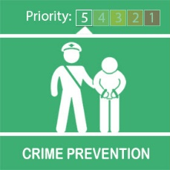
  Bogus Callers

Dear Tony Good afternoon
During these unprecedented times it good to be mindful of your security at home and reminder that people shouldn’t be calling at the door given the current government restrictions which are in place.
Always be on your guard when anyone you're not expecting - a man, a woman or even a child turns up at your door.Bogus 'officials' may be smartly dressed and claim to be from the council, gas board, health authority or other organisation.
Bogus 'workmen' may say that they need to come in to check something or make urgent repairs. They may even claim to be police officers. Genuine callers will normally make an appointment first and will carry identification with their photograph on.
What to do if someone calls at your door:
Check to see who it is by using the spy hole if you have one, or look through a front window
Always put the chain on before you open the door. (If you don't have a chain it's a good idea to get one)
Look at their clothing. Some official callers will have a uniform bearing their organisation's name or symbol
If you don't know the caller, ask to see their identity card. Check it carefully, and keep the chain on while you do this. Genuine callers won't mind if you close the door while you do this
Some public utility services (e.g. water, electricity, gas) operate a password system. Contact your local branch to find out more
If you're still not sure, ask the caller to come back later. You can then check their story by phoning the organisation or company they claim to represent. Look up the number in your own telephone directory. Don't rely on the telephone number on their card - it may be the number of a criminal’s partner
Bogus callers sometimes work in pairs. Beware of one distracting you while the other steals your property. The best practice is not to let them in
Ensure your back door is locked if you are answering the door to someone you don't know.
Watch out for anyone who says they're in a hurry. Don't let them pressure you. If in doubt, call a neighbour or friend
If you have any suspicions at all, don't let them in
If you're still not happy, phone the police - dial 999 - and tell them what's happened. And tell your neighbours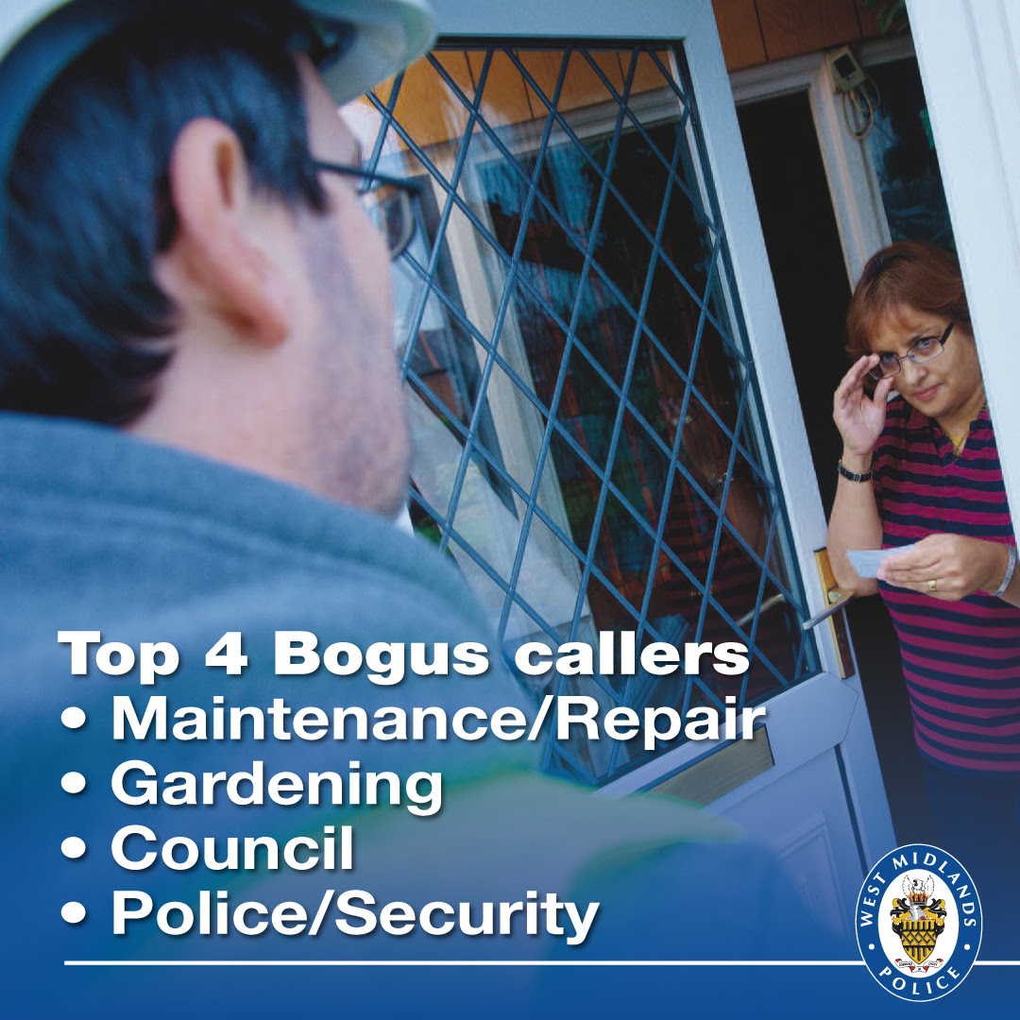
Kind Regards
Message Sent By
Georgina Johnstone (Police Staff, Engagement Officer, Birmingham)

