 | 12:05 (2 minutes ago)
  alert@neighbourhoodalert.co.uk
to me

  
  

  
  Coronavirus Update - from Your Local Police

Dear Tony
Six weeks ago, we were all asked to stay home, save lives and protect the NHS and we’re very grateful that the vast majority have listened and done exactly that.
On Sunday we'll find out more about how this may change moving forward, but with the Bank Holiday weekend fast approaching it’s important that we all still need to follow the guidance to stay home.
You’re all doing a great job under these very uncertain circumstances, and we know that together we can get through this.

Marking the 75th anniversary of VE Day
We know that some streets may be planning to hold lockdown versions of traditional street parties with neighbours having their own celebrations in their front gardens. This way, people can mark VE day while sticking to social distancing rules which are designed to save lives
This is not dissimilar to Clap for our Carers, which has been seen to build community spirit in a safe way, with people staying in their own gardens, with their own family.
Please remember that social distancing rules still apply and our policing approach remains to engage, explain, encourage and enforce as a last resort.
You can find out more about how you can mark the 75th anniversary of VE Day from home by visiting the Royal British Legion website.


No excuse for abuse
Being confined to our homes is stressful and can be an emotionally challenging time for all of us, but even more so for people experiencing domestic violence and abuse, whether physical or mental.
There is no excuse for domestic abuse, no matter the situation we find ourselves in.
If you or anyone you know is experiencing domestic abuse, then know that you are not alone. Support is always available to you.
Our new website – www.noexcuseforabuse.info gives you a range of help and advice.

Diary of a key worker
We’ve created a new ‘diary of a key worker’ series to bring you the personal stories of our officers and staff who are working across the force to keep you safe during this pandemic.
Graham Thomson is a resilience officer at West Midlands Police. He was meant to get married on 4 April and was planning his honeymoon in Italy for May.
Unfortunately, this has all been cancelled and instead he is part of the CoVID-19 co-ordination cell, working hard to ensure that the force can keep everyone safe and deal with the consequences of this outbreak.
He’s now planning an even bigger party to celebrate whenever he’s able to in the future.
Read more here.
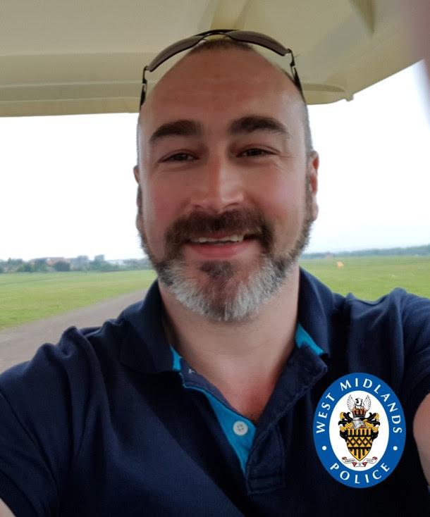

Contact us
It’s really important we keep our phone lines free so we can prioritise 999 emergencies and help those most at need.
For all non-emergencies please visit our website first. Here you can:
- Search for advice on a range of issues
- Report crime such as theft, criminal damage or burglary
- Speak to us on Live Chat between 8am to midnight
Stay safe and take care.
Unfortunately, we won’t be able to answer any replies to this message however you can speak to us via live chat on our website www.west-midlands.police.uk This is available every day between 8am and midnight, and the wait time is often less than calling us.
Message Sent By
Stefanie Sadler (Police, Engagement & Consultation officer, Birmingham Partnerships)

