  
  

  
  Bogus Caller

Dear Tony Willis
The below image is of a male calling at elderly vulnerable residents offering a service for cleaning gutters, he then steals money or alters the amount on cheques paid to him.
If you see this male please report to the Police on 101, 999 for an emergency or answer to this message.
Kind Regards
PCSO Gill Whittingham
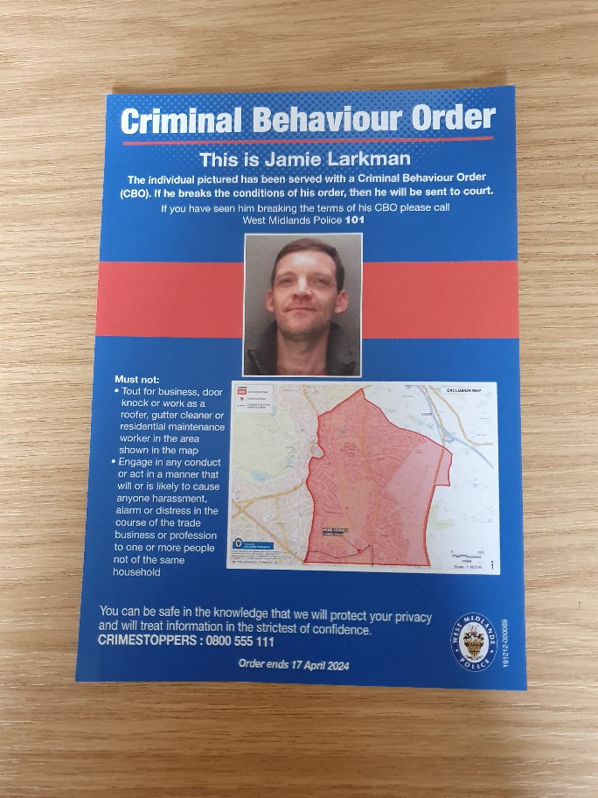
Message Sent By
Gillian Whittingham (Police, PCSO, Four Oaks)

