  
  

  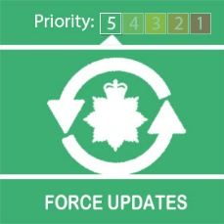
  Coronavirus Update from Your Local Police

Dear Tony

Earlier this week, many shops and businesses re-opened across the West Midlands following the Coronavirus lockdown.
Businesses have been busy putting plans in place to welcome customers to return and shop safely following social distancing restrictions.
As usual, we will continue to police the retail areas of our local towns and cities to prevent crime and keep you safe but we ask you to take personal responsibility when following the restrictions that are put in place by shops and stores.
We will continue to work with the retail industry but we are not able to police the measures they have in place to help shoppers follow government guidelines.
If you are travelling using public transport, please check what the arrangements are beforehand. If you are driving, check what car parks are open ahead of travelling.
We also ask you to use common sense and discretion when you are in and around
shops - observe the social distancing restrictions and continue to wash your hands and use face coverings to cover your nose and mouth – this is essential on public transport.
We have seen the tremendous efforts of people in the West Midlands, throughout the lockdown we have only had to enforce the government regulations on a few occasions so far. We know the vast majority of people will continue to do their bit and follow guidance in this next stage of easing restrictions.
We’re incredibly grateful for the support that you have given us over the recent weeks as we all work together to keep the region safe and healthy through this incredibly difficult time.
Click here for more information on how to stay safe outside your home.
Get the latest advice on how you and your loved ones can stay healthy, and what to do if you fall ill, from the NHS here.

Street Watch is back
After a break of more than two months to stay safe during the lockdown, Street Watch is back.
Street Watch are friends, family and neighbours who get together to make a difference in their neighbourhood.
With some training from us and a high visibility jacket, they patrol their streets in small groups. As well as being a friendly face, Street Watch members report things like anti-social behaviour, dumped rubbish and abandoned cars to us, the council or another organisation.
Groups across the West Midlands are making a real difference. Some have returned stolen cars with their owners, others have stopped kerb crawling, some have just made the place more friendly.
If you’re interested in becoming part of a group near you or want to set one up, email: streetwatch@west-midlands.pnn.police.uk
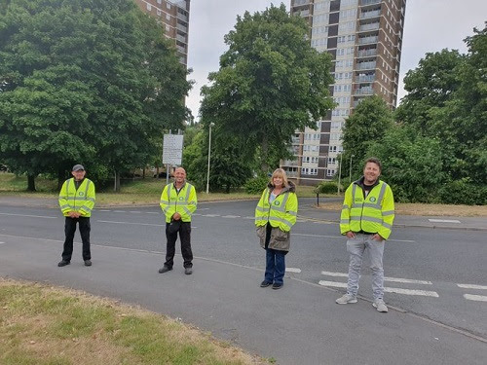

Moving forward
We hope that you have found these weekly Coronavirus updates helpful.
As we move forward, we have decided we will no longer send weekly Coronavirus specific updates but instead we will send you updates as and when there is new information or guidance that we need to share with you.
You will still continue to receive your general local policing updates from your neighbourhood teams.

Contact us
It’s really important we keep our phone lines free so we can prioritise 999 emergencies and help those most in need.
For all non-emergencies we ask you to visit our website first. Here you can:
- Search for advice on a range of issues
- Report crime such as theft, criminal damage or burglary
- Speak to us on Live Chat between 8am to midnight
Unfortunately, we won’t be able to answer any replies to this message. However, you can speak to us via live chat on our website www.west-midlands.police.uk This is available every day between 8am and midnight, and the wait time is often less than calling us.
Message Sent By
Stefanie Sadler (Police, Engagement & Consultation officer, Birmingham Partnerships)

