  
  

  
  Covid -19 Update from Your Local Police


This week we're celebrating national Volunteers Week and we'd like to say a huge thank you to every single one of our 485 volunteers.
Many of you have gone above and beyond to help us during this pandemic and we can't thank you enough for all the work you do across the West Midlands.
If you’re interested in volunteering for the force, please visit our Volunteers section on our website to find out more.

How we’ve been working with retailers in the West Midlands
As more shops start to reopen we wanted to let you know how we’ve been working with retailers over the past few months to keep you safe.
This has been a really difficult time for retailers, with many stores having to close their doors not knowing when they will be allowed to open again. Essential stores which have remained open have had to change how they operate to adhere to social distancing, which we know hasn’t been easy.
We’ve tried to support retailers through this time by linking up with the National Business Crime Centre to provide advice on a variety of issues including – from helping businesses to keep their premises secure while they are closed to helping businesses which remain open to create a safe and secure environment.
We want to say a huge thank you to all retail workers for all they have done as key workers during this pandemic – you have kept us going and for that we are truly thankful.
Please remember that it’s still important to continue following social distancing rules while shopping.

Our 'special' support
Since the lockdown we have seen amazing support from our specials who have volunteered over 11,700 hours in the last nine weeks alone.
We have over 200 special officers who continue to support us during the pandemic. National Volunteers Week is the perfect chance to highlight all their great efforts and recognise the positive difference they’ve made.
Find out more about how our specials have helped WMP here.
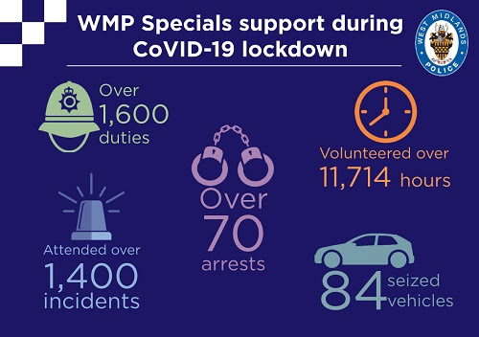

Diary of a key worker
This week, we’re featuring Martin Binks in our ‘Diary of a key worker’ series. The series brings you the personal stories of our officers and staff who are working across the force to keep you safe during the pandemic.
Martin volunteers as a ‘befriender’ and his role involves phoning vulnerable people to ensure they are ok, getting essentials delivered and just talking to people who are feeling alone.
You can read Martin’s story and see the other diaries of key workers here.


Contact us
It’s really important we keep our phone lines free so we can prioritise 999 emergencies and help those most in need.
For all non-emergencies we ask you to visit our website first. Here you can:
- Search for advice on a range of issues
- Report crime such as theft, criminal damage or burglary
- Speak to us on Live Chat between 8am to midnight
Stay safe and take care.
Unfortunately, we won’t be able to answer any replies to this message. However, you can speak to us via live chat on our website www.west-midlands.police.uk This is available every day between 8am and midnight, and the wait time is often less than calling us.
Message Sent By
Stefanie Sadler (Police, Engagement & Consultation officer, Birmingham Partnerships)

