  
  

  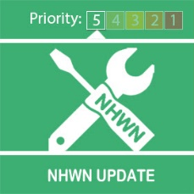
  Neighbourhood Watch Week 7th-13th June 2020

Dear Tony
Almost there!!
Celebrate NHW week by either joining a scheme, local to where you live or having your own watch.
You can have as many or as little members in your scheme it's your choice. Its easy to stay connected with neighbours.
- You can message and share news to all your scheme members from the Ourwatch platform/site.
- Your scheme will be fully insured by Ourwatch once it is registered
- We will issue you with new signage for your street lampposts and window stickers for your neighbours to display.
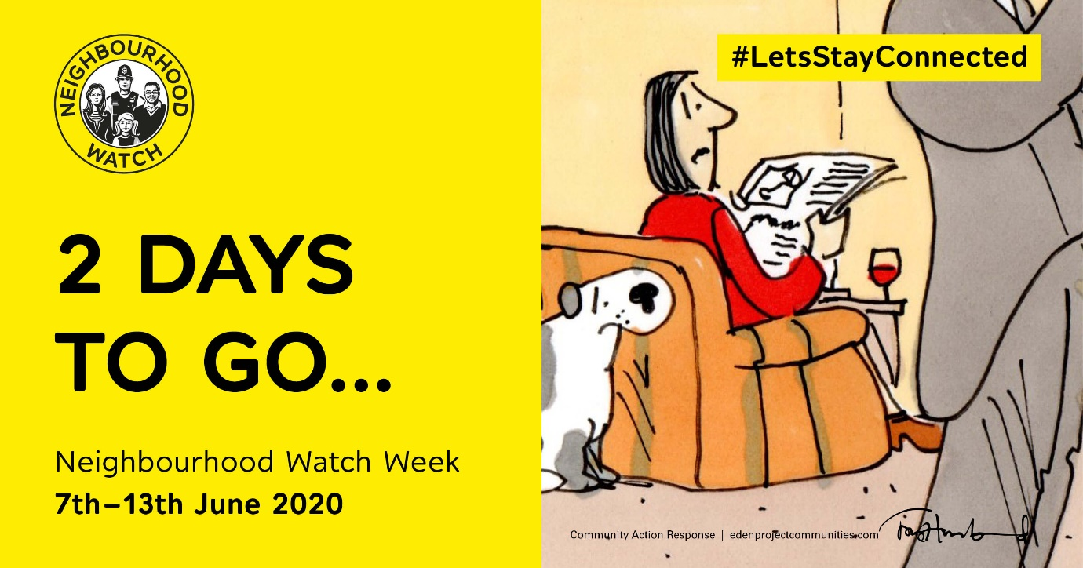
Let Ourwatch help you keep the neighbourliness spirit going! What are you waiting for?
The website has everything you need to know. Check it out here http://www.ourwatch.org.uk
Kind regards
Message Sent By
Stefanie Sadler (Police, Engagement & Consultation officer, Birmingham Partnerships)

