  
  

  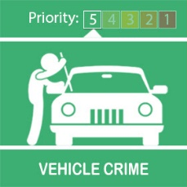
  Vehicle Crime Prevention

Dear Tony
Over the Weekend there has Been 2 Thefts of Motor Vehicle in the Sutton Vesey Ward.
They are not related as they took place at opposite ends of the Ward.
We would like to remind you of a couple of Crime prevention tips:-
1/ Never leave valuables on display in your car, even if you are just 'popping' into a shop for some essential bits pieces
2/ Always check 'Your Fob Has Done Its Job'. When locking your car by remote, please check the car has locked.
3/ We recommend that you purchase a 'Steering Wheel Lock' for your vehicle
Best regards
Sutton Vesey Neighbourhood Poliocing Team
Message Sent By
Ian Willetts (Police, PCSO, Sutton Coldfield)
  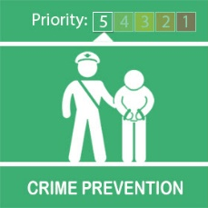
  Phishing Email Reporting Service

Good evening, hope you are all well.
Just wanted to highlight a new reporting service from the National Cyber Security Centre around Phishing emails.
Unfortunately Phishing is still a popular bait to use for criminals, Please don't take the bait, if something doesn't look right then it probably isn't, act upon your instincts.
If you want to report any Suspicious emails then please forward them on to report@phishing.gov.uk or any suspicious text messages then please report to 7726 free of charge from you phone.
Check out the link below for visual and audio guidance around Phishing and the new reporting service available by the National Cyber Security Centre. Regional Cyber Crime Team Phishing Video
Thank you, stay safe
Sean
Message Sent By
Sean Long (Police, Digital PCSO, West Midlands)
  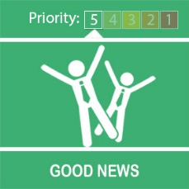
  Bike Marking

Dear Tony Willis,
Starting this week the Vesey NHT are offering free Bike Register marking for your bicycle.
The Bike Register kit, like a car VRN plate marks your bicycle with a unique code which will register your bicycle in your name and address. Once registered your bike and details will be placed on an online database which Police across the country use to reunite victims of crime with their stolen bicycles.
If you are interested in having your valuable bike marked please contact us via e-mail to
suttonvesey@west-midlands.pnn.police.uk
Kind Regards
Ian Florence
Message Sent By
Ian Florence (Police, PCSO, Birmingham East Sutton Vessy)
  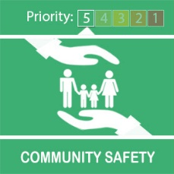
  Illegal Music Events

Dear Tony Willis ,
We are now responding to a national emerging trend of illegal music events ongoing across the UK.
As you may be aware, we have had a number of concerns around Sutton Park recently with anti social behaviour and littering, and would not want anybody thinking this could be a suitable venue for any illegal music events or gatherings.
Anyone who is found organising these kind of events faces the prospect of us seizing equipment and prosecution.
We are calling on the public to help us. If you have any intelligence or hear about an event taking place, please get in touch with us so we can prevent it and ultimately save lives. The key to stopping these events is early intelligence.
An illegal rave near Lichfield in Staffordshire last weekend attracted several hundred people and saw police issue warnings to parents who were found dropping their children off to attend the event. Five people have been arrested in connection with being involved in the organisation of such event in Chasewater Staffordshire.
There are no safety measures in place at these unauthorised events. If anything goes wrong and you, or your son or daughter, are attending, the emergency services might not be able to help you as quickly as normal.
The illegal rave in Manchester not only ended in one man dead, but another stabbed and there was a report of a serious sexual offence against a woman. These are not safe events and parents should be actively deterring their children from attending.
Everyone needs to act responsibly to keep our communities safe.
If you suspect a rave or illegal gathering is being organised or there is suspicious activity, contact us on Live Chat via our website or call 101.
Kindest regards
Sgt Heather Jones
Sutton Vesey Neighbourhood Team
Message Sent By
Heather Jones (Police, NPU Sgt, Birmingham East - Sutton New Hall)

