  
  

  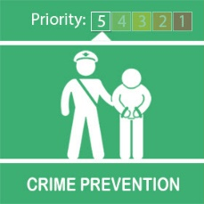
  Cyber Crime Sentinel

Good afternoon all, hope everyone is staying safe.
Please see the attached link below to view our Cyber Crime Newsletter, Cyber Sentinel issue 11, brought to you by the Regional Cyber Crime Unit.
Here you will find information about current threats and news from across the region.
We welcome your feedback around our newsletter so feel free to get in touch.
Check out our newsletter on our website here - www.wmcyber.org
Have a great weekend
Sean
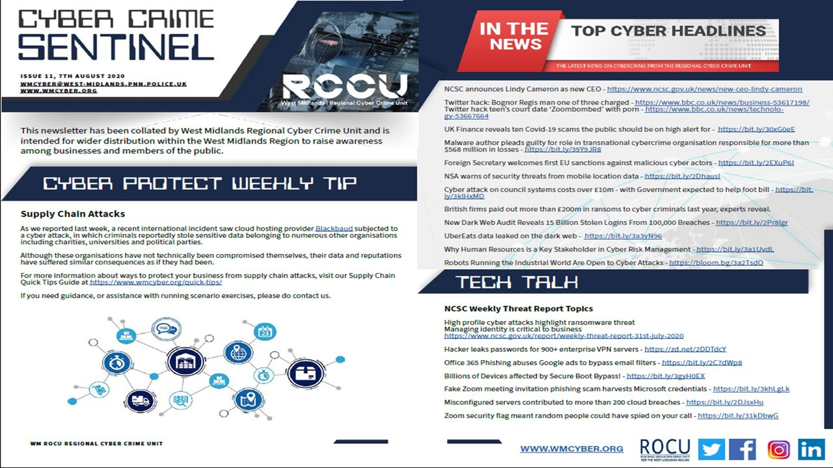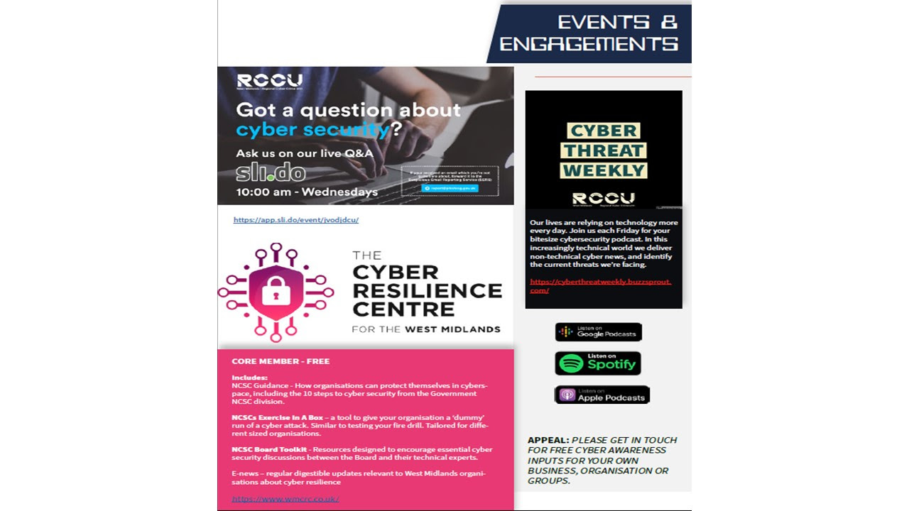
Message Sent By
Sean Long (Police, Digital PCSO, West Midlands)
  
  Sutton Park

Due to the recent issues at Sutton park a S.35 Dispersal Notice has been authorised.If you have any concerns please contact us on 101 or 999 if an emergency.
Kind Regards
PCSO Singh
Message Sent By
Satpal Singh (Police, PCSO, Birmingham East BEGD )

