  
  

  
  Hello from the Wmp Commonwealth Games Team

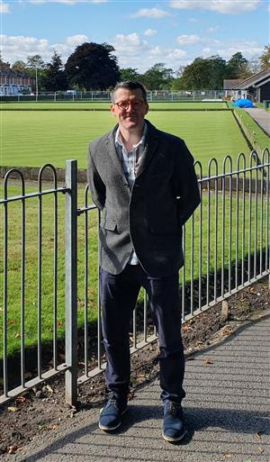
Dear Tony
I'm getting in touch as you have said you're interested in hearing more about WMP's work with the Birmingham 2022 Commonwealth Games.
As part of the WMP community engagement team, I'll be your main point of contact for the Games and I want to hear from you about what information you want to receive in the run up to and during the Games period.
As the host city force, WMP are looking forward to delivering a safe, secure and welcoming Games.
We are working closely with the Birmingham 2022 team, the local authority, partners & neighbourhood teams but we also want to make sure we work closely with you, as it's vital that you have a say in how we work in your area.
This is an amazing opportunity for the region but we appreciate that major events have an impact on the community & residents.
In the coming weeks keep an eye out for a survey I'll be sending via WMNow so I can capture your thoughts. If you have anything you want to share with us or ask about in the meantime , feel free to reply directly to this message or email os_cwg2022@west-midands.pnn.police.uk.
We’ll be keeping you up to date with developments via WMNow but you can also follow us on Twitter @cg2022_wmp where you can also get in touch.
It would be great to hear from you so we can make sure we’re keeping you up to date with what matters to you most. If this is helpful, make sure you let us know by rating this message below.
Here's to a fantastic 2022!
Looking forward to hearing from you.
Jim
Sergeant Jim Carroll
Attachments
pic1.jpg - 1,566.4 KB
Message Sent By
James Carroll (Police,Sergeant,Commonwealth Games)

