  
  

  
  Arrests Sutton Coldfield

Good Afternoon Tony Willis,
The neighbourhood team have had a great couple of days with a number of arrests.
A male and female were arrested yesterday in Sutton Coldfield on suspicion of burglary.
Today a male has been arrested on suspicion of a domestic assault.
Great results for the teams!
I have attached some burglary advice for residents, particularly now we have the darker nights.
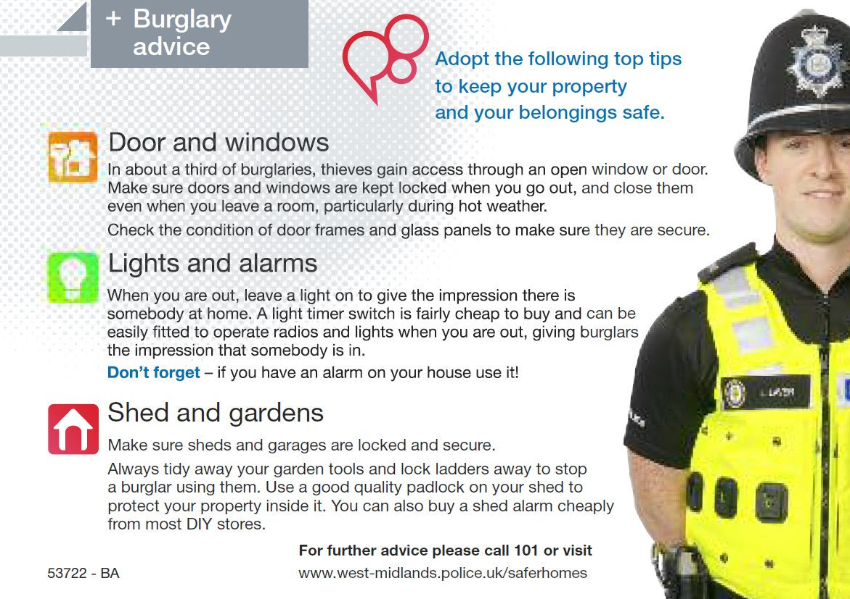
Kind Regards
PCSO French 31559
Sutton Newhall Neighbourhood Team
Message Sent By
Rachel French (Police,PCSO,Birmingham East)

