November Frosty Morning
So, we had our first heavy frost of the year last night. That means winter is just around the corner.
The tedious job of de-icing a frozen windscreen is about to become part of everyone's morning routine as winter approaches.
So just a reminder that if your car is frosted over please try to avoid leaving it running while you are not present. This increases the risk of someone being able to drive away in your car. It is also an offence to leave your car engine running unattended.

Please make sure your car is completely defrosted before driving on the road, as this could be a danger to yourselves and other road users by restricting your vision.
Most of all, please be cautious of your driving when the road conditions are wet and icy.

Stay safe, kind regards

Message Sent By
Stefanie Sadler (Police, Engagement & Consultation officer, Birmingham Partnerships)

Neighbourhood Watch Ournews November E-Newsletter
Our popular monthly newsletter OUR NEWS November 2020 edition is here!

This month we introduce you to our new Spotlight on Associations feature starring Cumbria Neighbourhood Watch, and our new cybercrime campaign which we will be launching imminently.

We take a moment to celebrate our volunteers and the fantastic contributions they have made, and we share ways in which we can support you through the Covid-19 crisis.

We also take our first look at the findings from our recent Neighbourhood Watch England and Wales Crime Survey. And finally, in the run up to Christmas, don't miss out on exclusive member offers from ERA!

Read it all here
Kind regards, NEIGHBOURHOOD WATCH NETWORK, Central Support Team

Lockdown Update - We Are Here For You

Changes to our service

We do not underestimate the impact the previous lockdown had on you. We thank you for your efforts in helping keep each other safe. Together we were able to reduce the spread of the virus, prevent the NHS from being overwhelmed and save lives.

With the announcement of a second lockdown we want to reassure you that we’re still here to prevent crime, protect the public and help those in need.

However, to minimise the spread of the virus and protect our own staff means at times we may have fewer team members in our contact centres. Our staff are helping out as much as they can from home, however it may take a little longer to get in touch, especially if you try to call us.

How you can help

It is really important we keep our phone lines free so we can prioritise 999 emergencies and help those most in need.

We find that many of the calls we receive can be resolved online.
Help us so we can help you. For all non-emergencies we ask you to visit our website first. Here you can:
- Search for advice on a range of issues
- Report crime such at theft, criminal damage or burglary
- Speak to us on live chat between 8am to midnight
- Report potential COVID-19 breaches

You'll find that everything you can do by calling 101, you can do on the website and live chat.

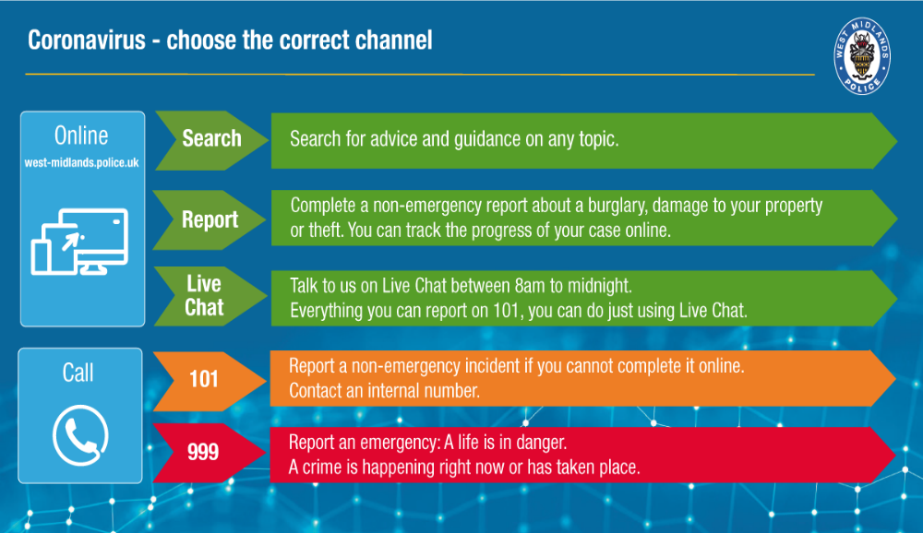

Enforcing the guidelines

Your efforts during the last lockdown reduced the spread of the virus. We’re now asking you to show the same resolve and keep following the government guidelines. We understand it’s difficult but we all have a part to play in protecting ourselves, our families and each other by following the advice.

We are enforcing government measures, which we know the majority of you will follow. Unfortunately it’s a minority who are put others at risk.
As you’d expect our priority will always be to continue to respond to crime and prioritise the most serious of crimes. You can trust that we are using our powers to stop significant breaches by issuing fines or dispersing large gatherings.

Visit our coronavirus specific page to see how we’re supporting you through this health emergency and how to report anyone not following the guidelines.
Keep following the government advice by staying at home and only going outside for essential food, health, work and education.
Wash hands. Cover face. Make space.
West Midlands Police
Message Sent By
Asim Janjua (Police, Digital Communications Officer, West Midlands)

