ZOOM

THE MOST POPULAR VIDEO MEETING APP
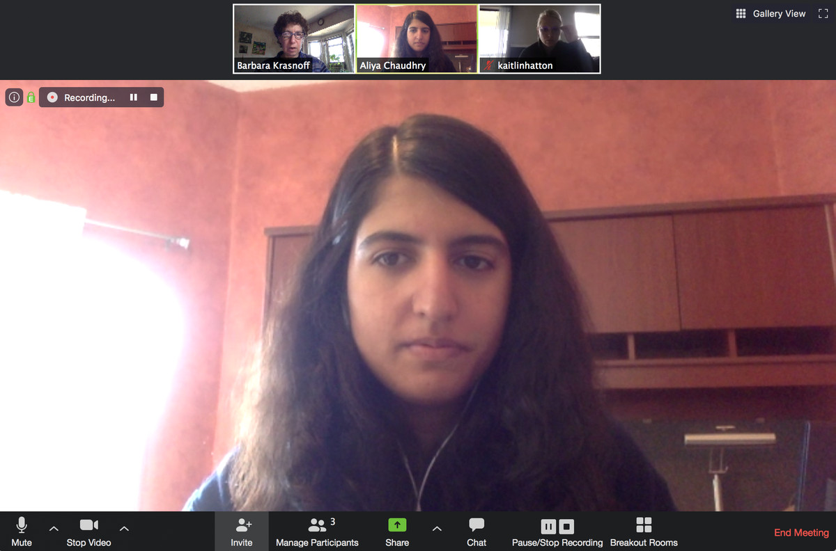

Zoom’s ease of use and multiple features has made it very popular.
Zoom has become one of the most well-known videoconferencing apps, largely because of its easy-to-use interface. Originally, the company pushed Zoom mostly for corporate use, but it has also provided a free basic version for individuals. At first, because Zoom didn’t expect its sudden popularity among non-business users, there were several missteps involving privacy and security. However, the company quickly instituted a number of changes and updates to address these issues (including, most recently, end-to-end encryption for its free users). And its popularity doesn’t appear to have suffered.
The free version of Zoom allows up to 100 users to meet, but there is a 40-minute limit on meetings of more than two people, which is, for many of us, pretty limiting. As of this writing, Zoom was not offering any special deals for those now working at home, but it does have a page offering help and advice to new users.

NOTEWORTHY FEATURES
- Host up to 100 participants
- Unlimited one-on-one meetings
- Forty-minute limit on group meetings

SKYPE MEET NOW

A LONGTIME GO-TO FOR ONLINE CALLS
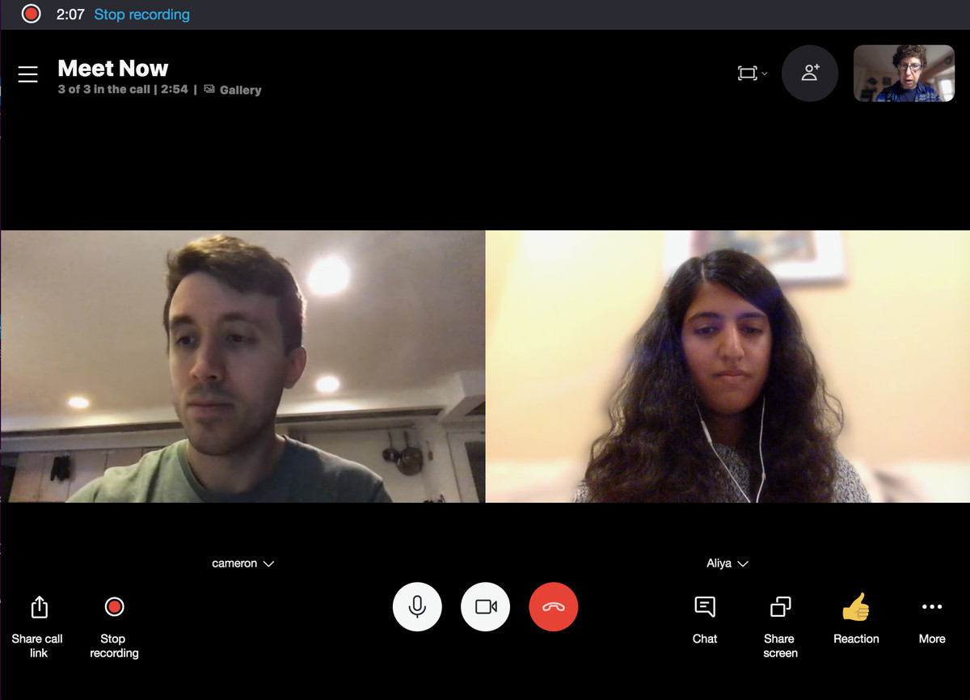Skype, now part of Microsoft, has added videoconferencing to its VoIP features.
Skype has been the go-to platform for one-on-one conversations since the beta was released in 2003. Its Meet Now feature (which is accessed by choosing the “Meet Now” button on the left side of the app) allows videoconferencing; up to 50 people can meet with no time limits on meetings.
There is also a separate page that lets you create a free video meeting without having to actually sign up for the service. However, you get more features using the app, so if you’re okay with registering for a free account, you’re better off doing that.

NOTEWORTHY FEATURES
- Record the call for up to 30 days
- Can blur the background (if you have the app)
- Share presentations
- Up to 50 participants, no time limit

CISCO WEBEX

A CORPORATE APP WITH A SOLID FREEMIUM VERSION
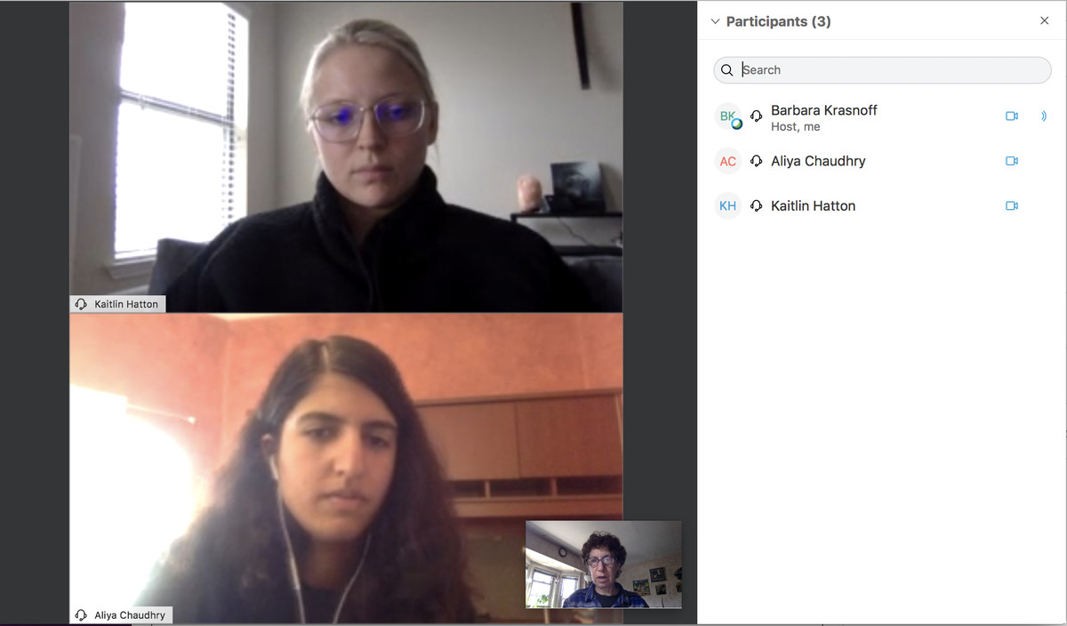Cisco Webex is a well-known business conferencing app.
Webex is a videoconferencing app that has been around since the ‘90s; it was acquired by Cisco in 2007. While it’s been mainly known as a business application and continues to focus on serving companies, it does have a fairly generous free version that’s worth checking out. For the current emergency, it has widened the features of the freemium version from 50 to 100 participants, and you can meet for up to 50 minutes.

NOTEWORTHY FEATURES
- Up to 100 participants
- Up to 50 minutes for each meeting
- Can record meetings and save locally

GOOGLE MEET

NOW BEING FEATURED ON YOUR GMAIL PAGE
Google Meet recently became available to Gmail users.
Until recently, Google Meet (formerly Hangouts Meet) was only available to educators and those subscribing to Google’s paid service, G Suite. Since then, Google has made Meet available to all users of its free Gmail service — in fact, it has added a link to Meet on the left side of its Gmail online app (and is rolling it out to its mobile apps as well).
Meet offers a very simple way to video chat with colleagues, friends, and family — assuming they all have Google accounts, which is a requirement for both hosts and participants. To start, simply go to Meet, click on “Join or start a meeting,” give the meeting a name (if you want), and send out your invites. You can also schedule a meeting using Google Calendar, and Google includes a number of security features such as the ability to admit or deny entry.

NOTEWORTHY FEATURES
- Unlimited meeting time until September 30th; afterward, 60-minute limit
- Up to 100 participants
- Offers noise cancellation feature

MICROSOFT TEAMS

A NEW MOBILE VERSION NOT JUST FOR BUSINESS 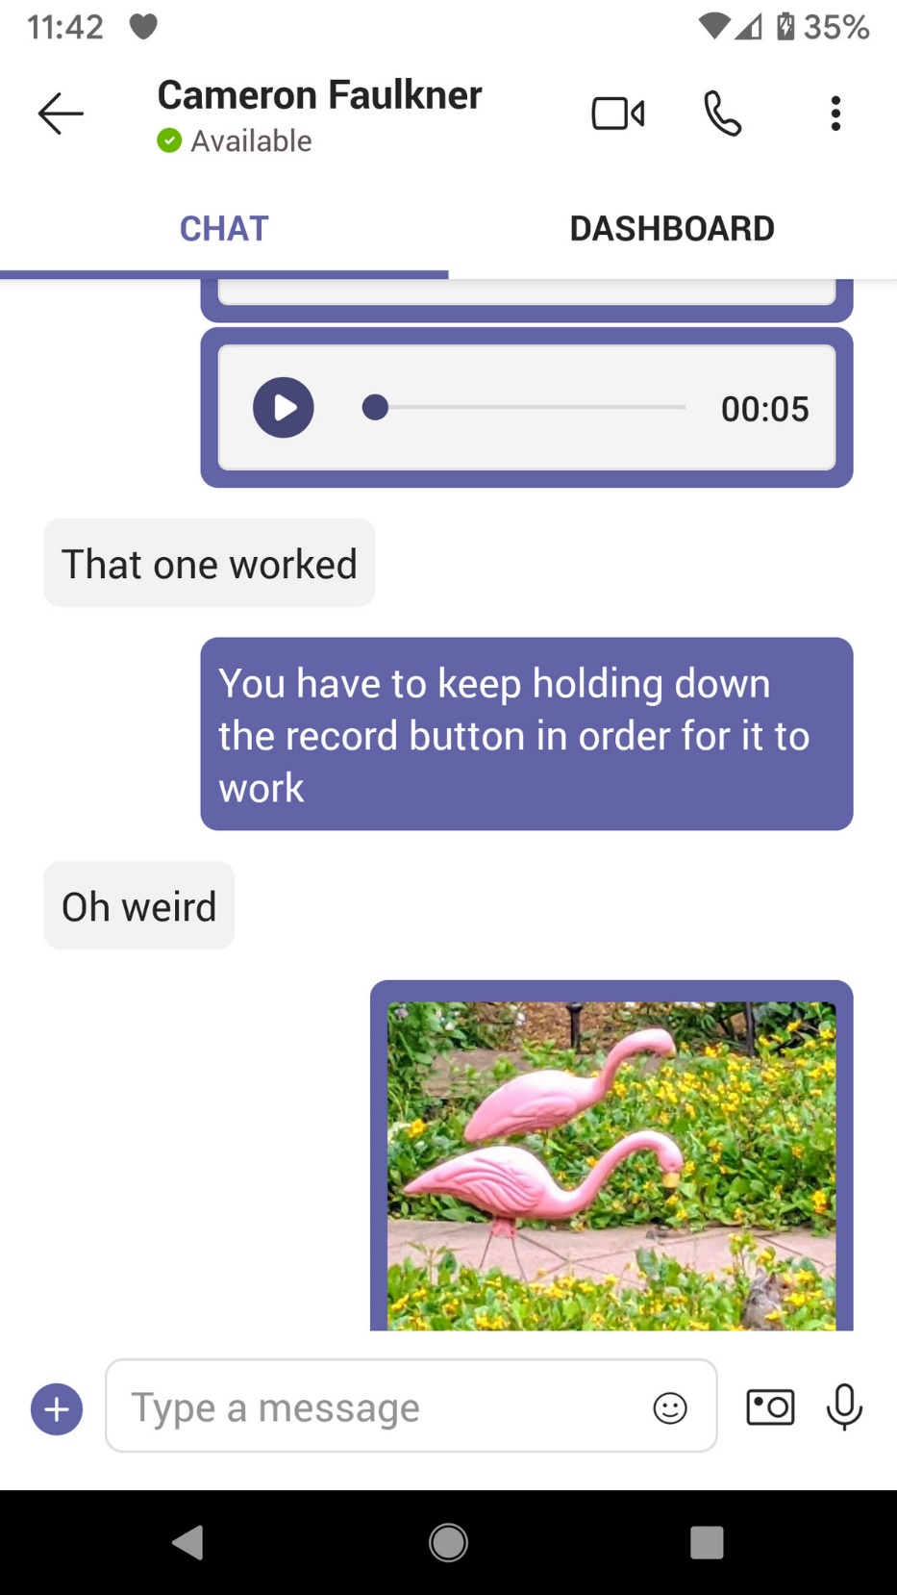Chats can include text, photos, and audio.

Teams’ video meeting features are basic but effective.
Microsoft Teams was built as a competitor to Slack and is an especially good idea if you’re part of the Office ecosystem. Until recently, it was mainly focused on business use. However, Microsoft has now stepped out of its three-piece suit and unveiled a free personal version of Teams that works on iPhones and Android devices (no desktop yet), and lets anyone chat, talk, or have video meetings with up to 20 people. You just have to create an account with Microsoft in order to use it.

NOTEWORTHY FEATURES
- Create groups of up to 20 people
- Can share your screen
- Text chats can include photos and audio files

GOOGLE DUO

A MOBILE APP BEST SUITED TO ONE-TO-ONES
Google Duo has a very simplistic web interface.
You don’t really expect Google to only offer one simple videoconferencing app, do you? Besides Google Meet (which is slowly replacing Hangouts, and which was originally meant to be mainly for business users), Google also has its mobile app Duo, which was built as a consumer app. The company recently added invite links to Duo, along with a very basic web interface. In addition, the app now allows you to create groups of up to 12 participants (but only on its mobile versions). All participants must be Duo users, which can be an issue for wider use.

NOTEWORTHY FEATURES
- Can record a message
- Create groups of up to 12 people
- Uses end-to-end encryption

HANGOUTS

SLOWLY BEING SUNSET, BUT STILL USEFUL
Google Hangouts is slowly being sunset, but it’s still available if you want to use it.
And finally, there’s Google Hangouts the “classic” version, which is still available, although the company is not promoting it, especially to G Suite users and corporate customers who are being encouraged to use Meet.
All that being said, if you’re feeling old-fashioned, you can use Hangouts to video chat with up to 10 people if you’re using Gmail or G Suite Basic (up to 25 if you’re using the business or educational G Suite versions). There aren’t a lot of additional features. You can add text messages and share screens, but that’s about it. Still, if you want quick and easy, this is worth checking out.

NOTEWORTHY FEATURES
- Up to 10 participants for Gmail users
- Voice conversations can have up to 150 participants

STARLEAF

A CORPORATE MEETING APP WITH A FREE BASIC VERSION
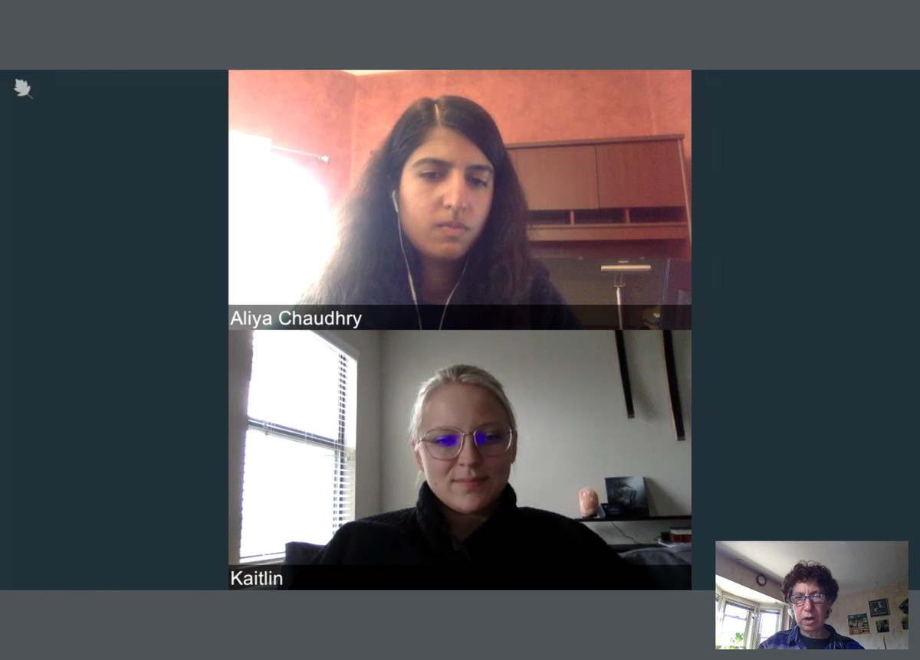Starleaf is an enterprise application that has a free version available.
If you’re not a company, you may not have heard of StarLeaf. It’s a platform for large companies — the kind that doesn’t quote a price on its website; you have to call a salesperson. But it is now offering its basic video and messaging product free of charge for those trying to keep in touch during the pandemic.

NOTEWORTHY FEATURES
- Up to 20 participants
- Forty-six minutes for each meeting

JITSI MEET

OPEN SOURCE WITH PLENTY OF FEATURES
Jitsi Meet is an easy-to-use open-source video platform.
Another “you probably haven’t heard of it” videoconference app, Jitsi Meet is an open-source platform that lets you easily meet online by simply navigating to the site and clicking on “Go.” If you’re more technically inclined, you can build your own via Jitsu Videobridge, but most people will be happy with the quick web version, which offers many features found in more well-known apps, such as chat, session recording (to Dropbox), and the ability to “kick out” unruly participants.

NOTEWORTHY FEATURES
- Up to 75 participants (up to 35 for the best experience)
- Public or private chat
- Can blur the background (currently in beta)
- Integrates with Slack, Google Calendar, and Office 365

WHEREBY

SINGLE MEETING ROOMS WITH UP TO FOUR PARTICIPANTS
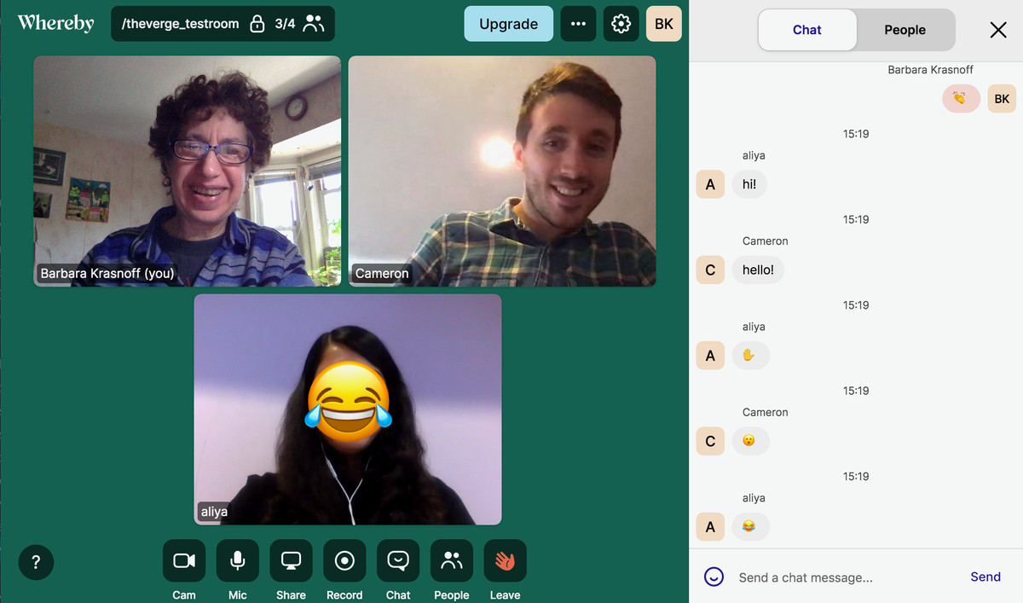Whereby’s free version is rather limited, but it has some fun features.
Whereby’s free version is rather limited compared to some others mentioned here. It gives you the use of a single meeting room with up to four participants, along with the ability to lock rooms (participants have to “knock” to gain entrance). Each room has its own URL that you get to choose, which is great — assuming that nobody else has already taken that name. (For example, I tried whereby.com/testroom and found it was already taken.) But it also has a chat function, lets you share a screen, mute or eject users, and has some fun emoji. If you have more people in mind, the Pro version ($9.99 per month) offers up to 12 participants per room in up to three meeting rooms.

NOTEWORTHY FEATURES
- Up to four participants in free version
- Screen-sharing
- YouTube integration
- Ability to “lock” rooms

SPIKE

AN EMAIL APP WITH A SIMPLE VIDEOCONFERENCING FEATURE
The Spike vide app has a very simple interface.
Spike is an email app that has been adding collaborative features since I reviewed it last year. With the current demand for online meetings, the company has recently added videoconferencing to its repertoire. The feature is very easy to use, especially since you don’t need to register or install anything to use it. Just go to the videoconferencing link, type in your name, and, optionally, a meeting topic. The meeting URL is then copied to your clipboard, or you can send an invite via email. There are few extras in this app: you can share your screen or stick up an emoji, but that’s about it, and the host has no control over the meeting. There are no limits on the number of participants or meeting time.

NOTEWORTHY FEATURES
- Simple interface
- No limits on participants or meeting times

MORE ALTERNATIVES
There is a wide range of other Zoom alternatives out there, as listed in this Twitter thread, including RemoteHQ, Talky, Highfive, and 8x8 (which acquired Jitsi in 2018). Some of these don’t have a free version; for example, BlueJeans, a more well-known option, starts at $9.99 per month for unlimited-time meetings with up to 50 participants.
Slack is mainly set up for text chat, but it does give you the ability to make voice and video calls as well. If you’re on the free version of Slack, you can make a video call to an individual. But if you want to host a meeting between several people, as opposed to a one-on-one conversation, and want to do it for free, you’ll need to look for an alternative.
Special mention should be made of Houseparty, a popular consumer app that lets up to eight people use a virtual room to chat. In fact, anybody can drop into a friend’s online session without an invitation (although you can “lock” your room to prevent intruders). However, it does demand that all participants register in order to use it — and registration includes your name, email address, birthdate, and phone number. So we didn’t include it among our recommendations.
Update June 12th, 9:27AM ET: This article has been updated to include 8x8’s acquisition of Jitsi in 2018.
Update August 7th, 11AM ET: This article was originally published on June 11th, and it has been updated to include the “personal” version of Microsoft Teams.

FEATURED VIDEOS FROM THE VERGE
00:0518:49


THE VERGE GUIDE TO WORKING FROM HOME

