Birmingham Weekly COVID-19 Statistics
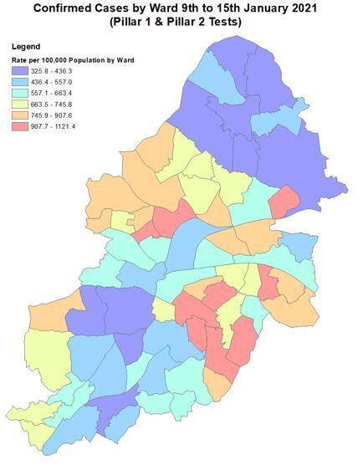
The wards with the highest case rates (per 100,000 residents) for 9 January to 15 January were:
- Lozells (1121)
- Sparkbrook & Balsall Heath East (1100)
- Hall Green North (994)
- Small Heath (985)
- Castle Vale (968)
- Sparkhill (962)
- Aston (944)
- Acocks Green (939)
- Yardley East (936)
- Hall Green South (908)
There are signs this week that the national lockdown is reducing case numbers, while the rates of testing are improving. However, there is still a long way to go to drop to the level we were at in the autumn - which was below 200 cases per 100,000 people.
Click here to see the full COVID-19 statistics dashboard.

