  
  

  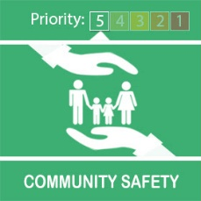
  Operation Sceptre is All About Cutting Out Knife Crime

Knife crime is a serious issue in many parts of the country.
It has tragic consequences and creates too many victims.
What are we doing about this?
West Midlands Police are conducting Operation Sceptre.
This week long campaign will see officers conducting weapon sweeps, knife arch operations , and extra high visibility patrols.
We will be working alongside colleagues from the British Transport Police to help keep our transport network safe from knife crime.
Indeed this morning neighbourhood team officers from Sutton Coldfield recovered a knife from Sutton Coldfield railway station.
That knife off the street will help make journeys safer.
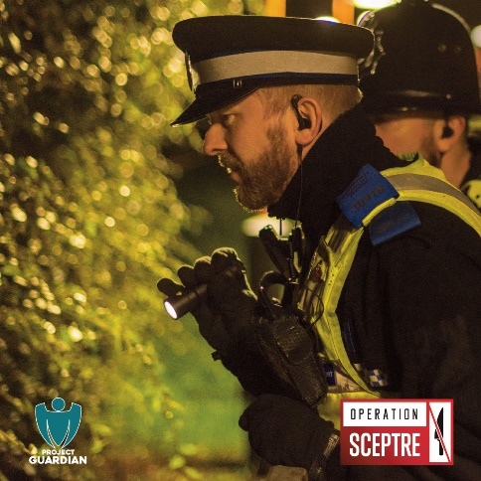
What can you do about this?
Safety is paramount .
If you see ,or suspect someone has a knife then call 999.
If you find a knife, make a note of its location and report this immediately.
If you think someone you know may be considering getting involved with knife crime, or has contacts with those that are then report this to the police or visit: www.crimestoppers-uk.org
Or call Crimestoppers on: 0800555111.
Message Sent By
Saul Smith (Police, PCSO, Four Oaks NHT)

