  
  

  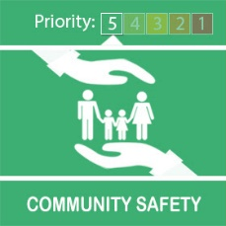
  We Are Staying Sharp on Operation Sceptre

Operation Sceptre is in full swing and we are working hard to reduce knife crime to help keep our communities safer.
What are we doing?
Local officers have been out conducting weapon sweeps in various locations.
As knife crime often involves and affects younger people we have joined forces with local secondary schools to set up and conduct knife arch operations.
These help detect and remove any items they may cause harm to in our communities.
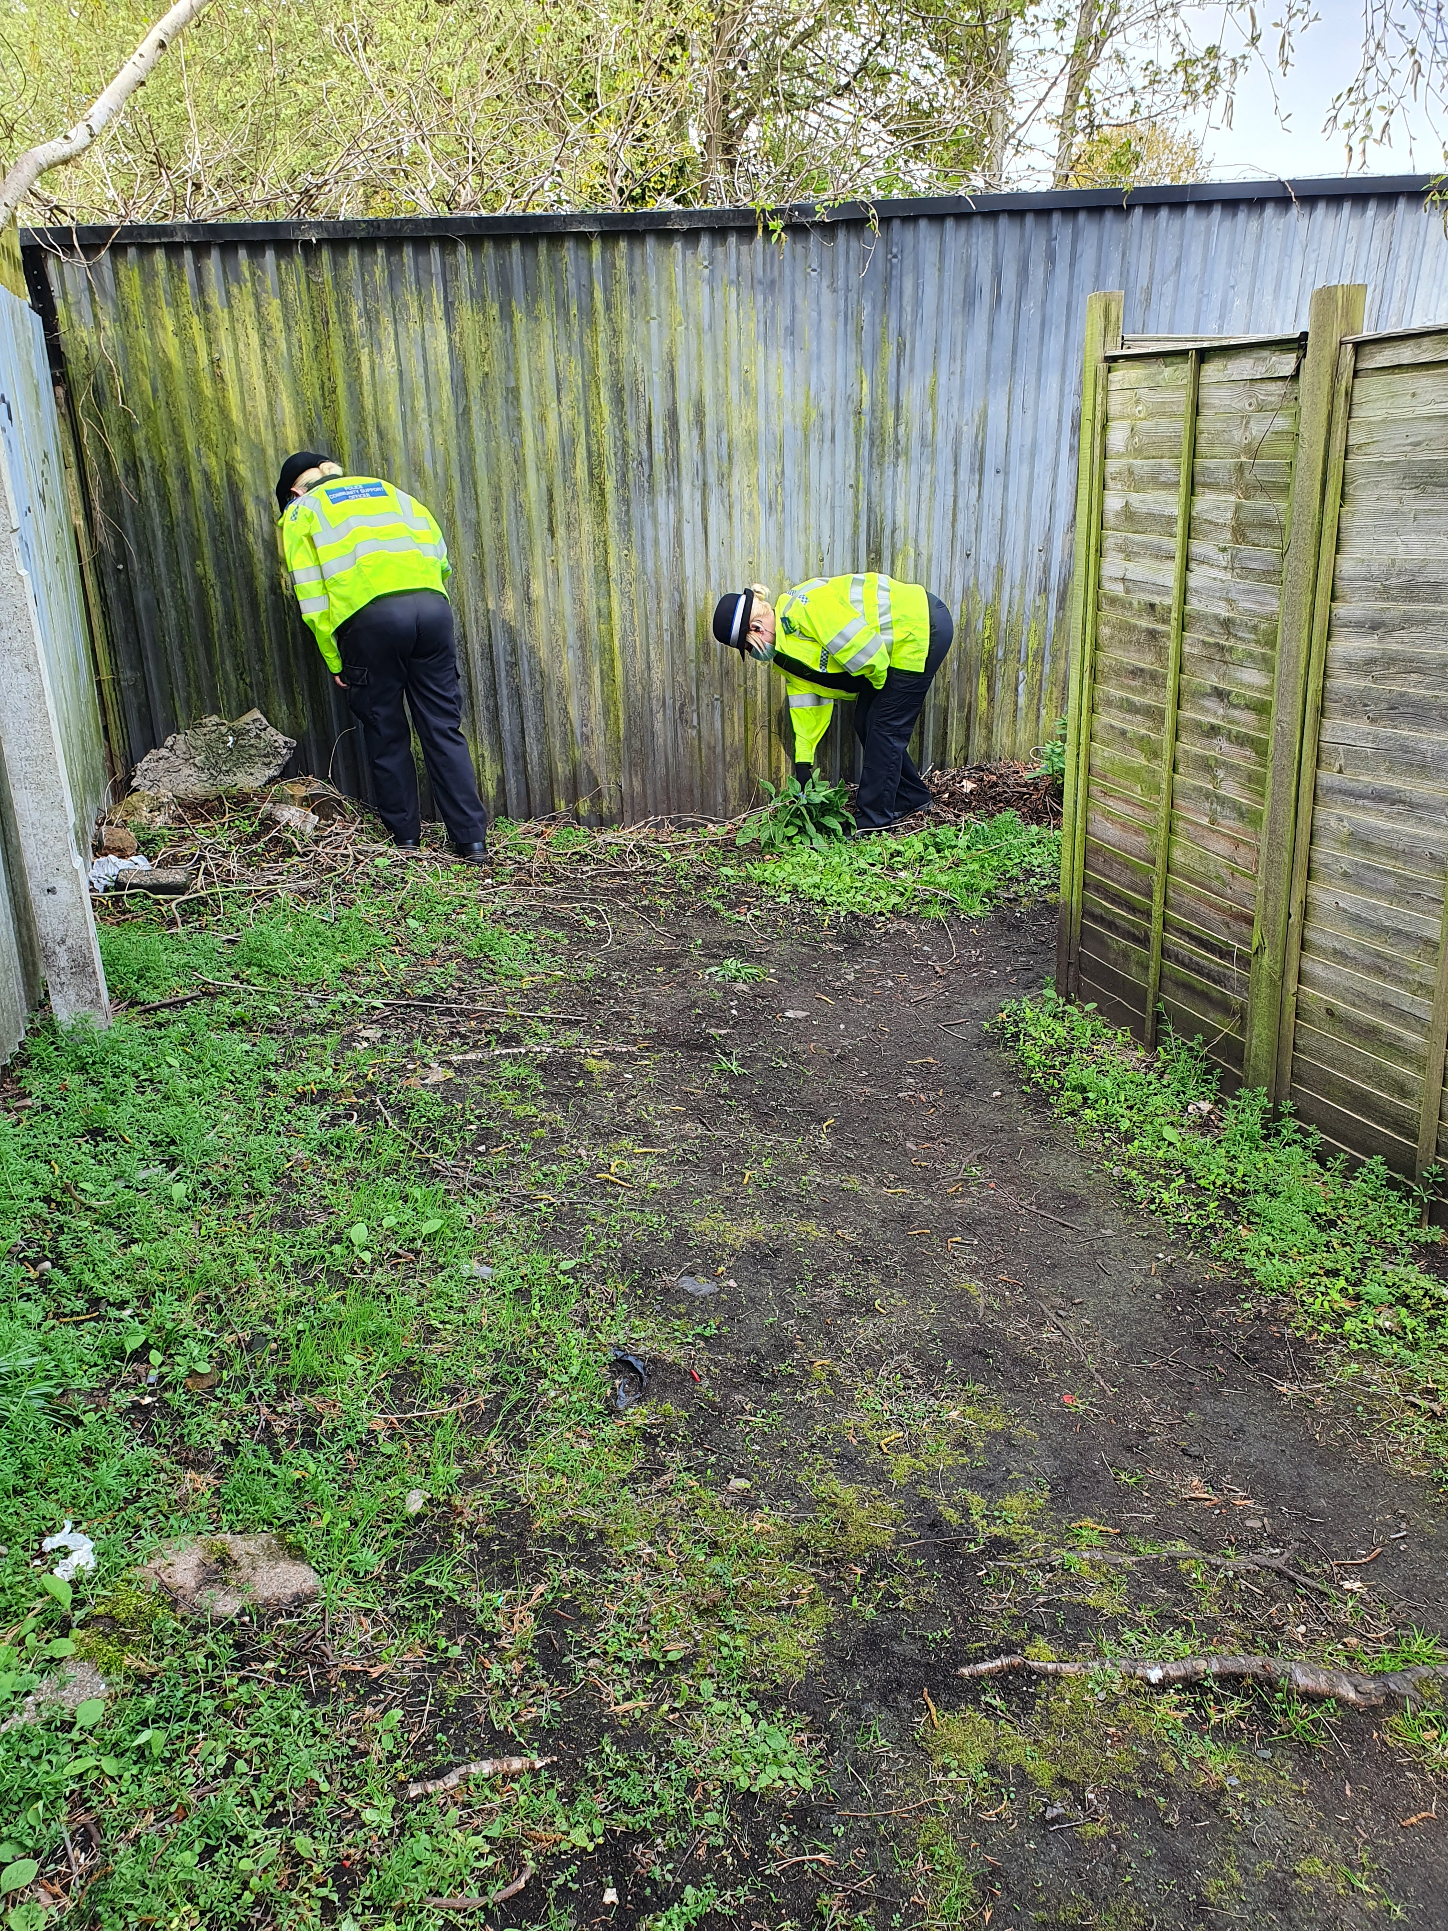
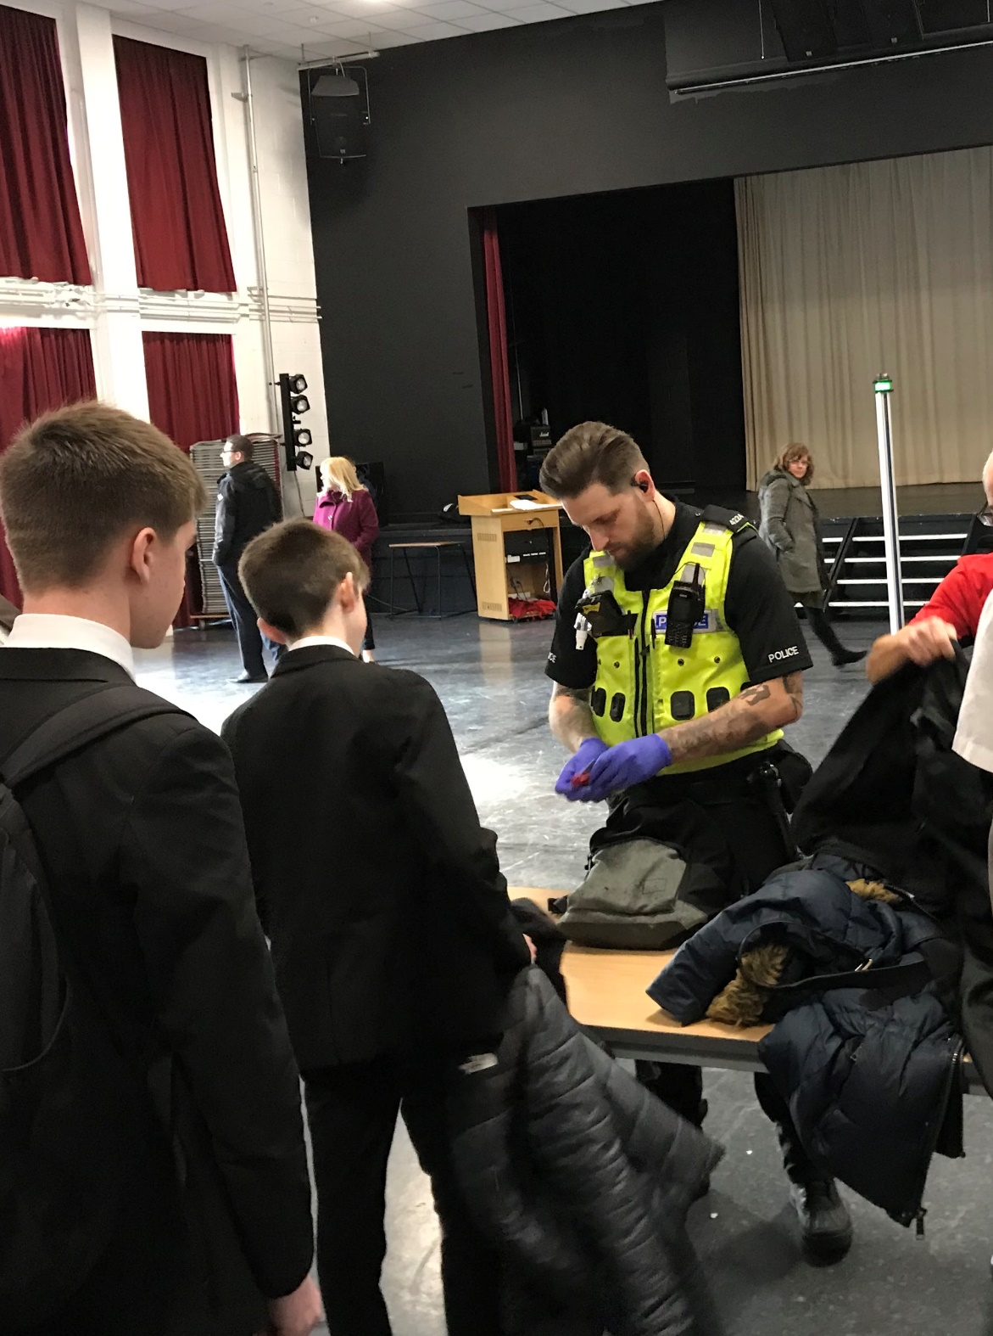
What can you do?
If you suspect some one is carrying a knife, or you hear that some one is planning to carry or use a knife then please report this immediately. You can do this via Live Chat at http://www.west-midlands.police.uk or by calling 101.
If you think a crime is in progress, or some one is in danger don't hesitate call 999.
You could help save a life.
Message Sent By
Saul Smith (Police, PCSO, Four Oaks NHT)

