What does Plan B mean for you?

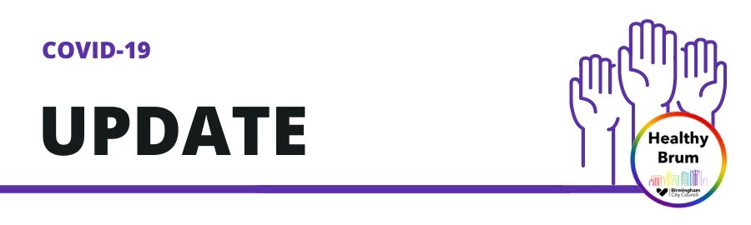

Dear Champions
Thank you all for continuing to share these important messages with your community. It has a been a busy news week, and as you begin to plan your weekend, we wanted to make sure you were up to date with all the new government guidelines in response to the spread of the Omicron variant. Please take the time to read and share this special edition newsletter - COVID-19: Moving to Plan B
This will include information about the new guidelines, changes to travel testing and when these will come into effect. There are also COVID engagement events taking place across the city THIS SUNDAY.
As always - stay safe, take care and thank you for all you do

Weekly COVID-19 Stats in Birmingham
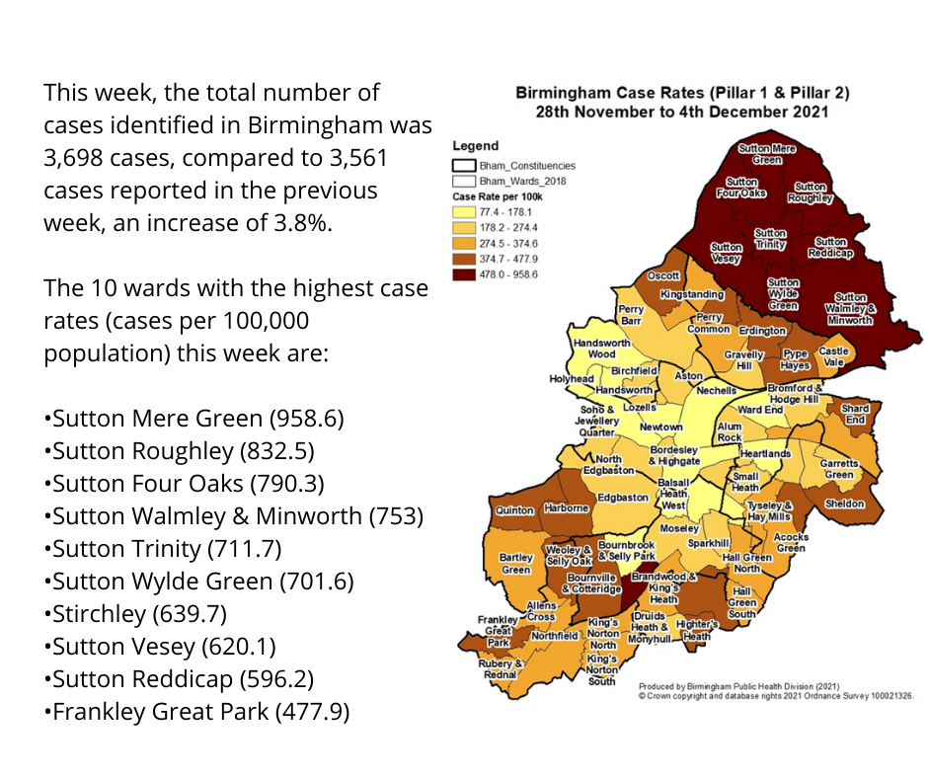

Moving to Plan B together
Over the last week, scientists across the world have been working to understand the impact of the Omicron variant of COVID-19. As a result the Prime Minister announced on Wednesday 8th December the plans for England to move to Plan B in order to reduce the spread of COVID-19
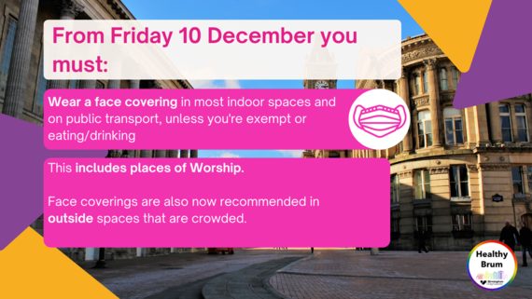

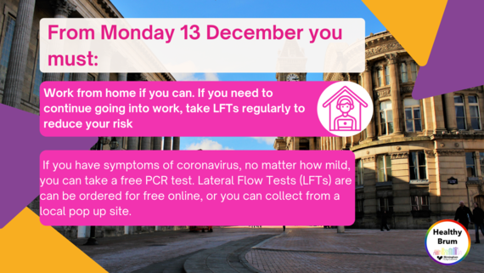
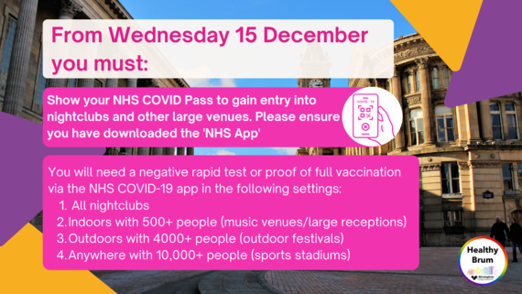

Vaccination, Testing and Self Isolation
- Stay home: If you have any symptoms of COVID-19, no matter how mild, stay at home and take a PCR test. You must stay at home until you either have a negative result or, if positive, you will need to follow the latest isolation rules.

- Isolate: You must self-isolate for 10 days - irrespective of your vaccination status or age, if you have been in contact with someone who may have the Omicron variant. You will be contacted by NHS Test and Trace.

- Test regularly: Take a rapid test (Lateral Flow Test) if you are going to be in a crowded space or before visiting people who are at higher risk of severe illness if they get COVID-19. You can order a rapid test for free online, or you can collect from a local pop up site. If you need to order lateral flow tests in bulk for your community groups and settings, please email: covid19communitychampions@birmingham.gov.uk

- Day 2 PCR tests: All international arrivals must take a day 2 PCR test and self isolate until they receive a negative result

- Covid-19 Vaccine: You can still get your 1st or 2nd vaccine from a walk in clinic across Birmingham and Solihull. This includes 12-15 year olds, who must be accompanied by a parent or guardian. You can also book an appointment using the National booking system. If you have had your 2nd dose more than 5 months ago, you are eligible to book your booster online. It has also been announced that those aged 18 – 39 will also be eligible for a booster when the NHS calls them

- Financial support: You may be eligible for financial support while you are self-isolating. See GOV.UK information on support for the latest.

Engagement event THIS SUNDAY 12TH December
The Cabinet Office Street Team has Birmingham on their radar!
The team will be visiting Birmingham this Sunday 12th December to engage one on one with local people about vaccines, testing and general public health safety messages. These locations include:
Newtown, Holyhead, Nechells, Soho/Jewellery Quarter, Birchfield and Bordesley/Highgate.
The team will also be supporting with signposting people to the nearest walk in vaccination clinics in the following locations:
- NuCare Pharmacy, 229 Victoria Road, B6 5HP
- Nishkam Pharmacy, 21 Soho Road, B21 9SN
- Afro Caribbean Millennium Centre, 339 Dudley Road, Winson Green, B18 4HB
- Shree Geeta Bhawana Temple, 107-117 Heathfield Road, Handsworth B19 1HL
- Iridium Medical Practice, 299 Bordesley Green East, B33 8TA
- Nechells Pharmacy, 56A Nechells Park Road, B7 5PR
If you are out and about this weekend, feel free to pop in and introduce yourselves as community champions and please share this information with your local communities.

Spread the word! Do you know someone who would be a great COVID-19 Community Champion? Please direct them to the Council Website where they can find out more and apply!
Kind regards
Healthy Brum
Birmingham City Council Public Health Team
Birmingham City Council
Send questions or suggestions to: COVID19CommunityChampions@birmingham.gov.uk

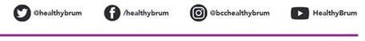

QUESTIONS? Contact Us

