At about 1.25pm today, Wednesday 16th, two youths wearing ski masks, and no helmets were seen on a red motor bike in Lockhart Drive B75. They will certainly know that they were seen. See the attached images.
If you see them again anywhere, report to the police by calling 101 or using Live Chat on WMP website. If they are committing a crime when you see them call 999.
Lockhart Drive is a small cul-de-sac. They are not known to the residents and they would have no reason to be there.
Did you see them today? Have you got anymore images of them from your doorcams or CCTV?
I feel sure that I have seen these before on pictures shared on social media.
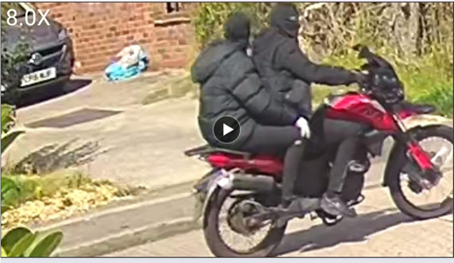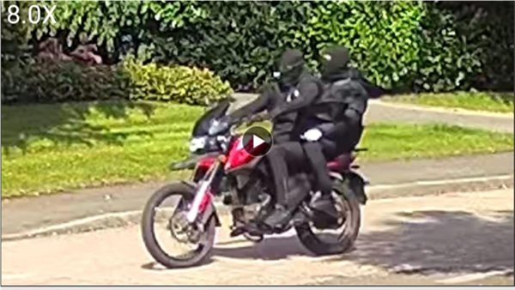
Take care.
Reg Banks,
Area Coordinator,
Neighbourhood Watch,
Sutton Coldfield

 | Message Sent By  Reg Banks (NWN, West Midlands Force Area)  ()

