  
  

  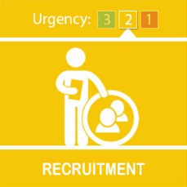
  We are recruiting!

Are you looking for a new career, where you can really make a difference?

Good news! We’re recruiting and have career opportunities to become a police officer or member of staff in one of our many specialist roles.

While training to be a police officer, you can earn £28,500 straight away and train for two years in our busy frontline teams, helping local people and making communities safer across the West Midlands. Within seven years you'll be earning over £46,000 - maybe more if you are promoted! Learn more about life as a student police officer by visiting our website – click here.

The opportunities don’t stop there…once you’re trained you could choose to stay in one of our Response teams, being the one who quickly responds to emergency calls, or perhaps you’d prefer to be part of a Neighbourhood Team supporting our local communities. Alternatively, there’s always options to become a detective, join one of our specialist teams, such as Public Protection, our Dog Unit, Firearms, Traffic or our Operations team.

If becoming a police officer isn’t for you, then we have thousands of staff who work in a range of roles across the force.

Our busy Contact Centre, based in Birmingham, is actively recruiting call handlers for our 999 and 101 lines. You can find out more, by clicking here. Contact handlers earn around £35,000 (including shift allowance), plus there’s part time roles available if that suits you better.

We are also currently recruiting for lots of specialist roles, such as:
· IT Support Officer
· Business Support Staff
· Forensic Collision Investigator
· PCSOs
· See all current vacancies here

If you’re keen to know more about life at WMP, you could join one of our Discovery Events – the dates can be found here.

Volunteering is also an option – be it as a Special Constable or in a specific volunteer role. All of the info can be found here.

If you want to know more, or have questions, feel free to contact our recruitment team, by emailing: careers@westmidlands.police.uk



